**Test Log**

|  |  |  |  |  |  |
| --- | --- | --- | --- | --- | --- |
| **Test No.** | **Test Steps** | **Expected Output** | **Actual Output** | **Result (Pass/Fail)** | **Pic number** |
| **NAVIGATION TESTS** | | | | | |
| **TESTING THE APP STARTS UP SUCCESSFULLY** | | | | | |
| **1** | **Start the application.** | The application launches and the Splash Page is displayed | As expected | **Pass** | 1 |
| **2** | **Press the login button on the splash page (details of login test is below)** | The login page appears | As exprected | **Pass** | 2 |
| **Testing the links at the top of the Home Page** | | | | | |
| **3** | **Press Each link on the home page** | The user is directed to the correct page.Home page is displayed | As expected | **Pass** | 3.4.5 |
| **Testing a staff member can log in** | | | | | |
| **4** | **On Staff/User Login Page-Enter an invalid Username and Password** | An error message is displayed | As expected | **Pass** | 6 |
| **5** | **On Staff/User Login Page- leave one or both fields blank** | An error message is displayed | As expected | **Pass** | 7 |
| **4** | **On Login Page-Enter the Username and Password of a registered Staff Member** | The user is taken to the home page | As expected | **Pass** | 8 |
| **Testing that staff can edit their details** | | | | | |
| **5** | **Click the Username on the top of the side bar** | The user should be taken to a “change your account settings page” | As expected | **Pass** | 9 |
| **6** | **Click the change your password link** | The user will be taken to a form | As expected | **Pass** | 10 |
| **7** | **On the change your password page – leave fields blank** | Error message is displayed | As expected | **Pass** | 11 |
| **8** | **On the change your password page – enter invalid information** | Error message is displayed | As expected | **Pass** | 12 |
| **9** | **On the change your password page – fill in the form with the correct Old Password, and a new password along with a matching confirm password** | A success message is displayed and the user can login with the new password | As expected | **Pass** | 13 |
| **Testing staff members can view shop products** | | | | | |
| **10** | **Press the “view all products link”** | The user is taken to a list of all the products separated by category | As expected | **Pass** | 14 |
| **Testing staff members can update stock level of a product** | | | | | |
| **11** | **Press the Update Stock Level link** | The user is taken to a form to edit the stock level. | As expected | **Pass** | 15 |
| **12** | **Leave the field blank and press the update button** | An error message will be dispalyed | As expected | **Pass** | 16 |
| **13** | **Fill In with a valid number and press update button** | The new quantity is saved in the database | As expected | **Pass** | 17,18,19 |
| **Testing staff members can view all customers and edit their details** | | | | | |
| **14** | **Press the view customers button In the nav bar** | A list of all the customers should be displayed | As expected | **Pass** | 20 |
| **15** | **Click the edit link** | The edit customer form is displayed | As expected | **Pass** | 21 |
| **16** | **On the Edit Customer**  **page attempt to edit while**  **missing out key pieces of**  **information** | Error message is displayed | As expected | **Pass** | 22 |
| **17** | **On the Edit Customer**  **page attempt to edit customer with valid information** | The changes are saves and the user is directed back to the view customers page | As expected | **Pass** | 23,24,25 |
| **17.1** | **Try editing the customer email(customer username)** | Should be uneditable | As expected | **Pass** |  |
| **TESTING VIEWING PREVIOUS ORDERS (AS A STAFF MEMBER)** | | | | | |
| **18** | **Press the view customer orders link** | The customer orders are displayed in a list ordered by order id | As expected | **Pass** | 27 |
| **19** | **Select a specific customer email from the drop down box** | That customers previous orders will be displayed | As expected | **Pass** | 28 |
| **TESTING VIEWING PREVIOUS ORDERLINES (AS A STAFF MEMBER)** | | | | | |
| **20** | **Press the view order link** | The individual order page is displayed with all the orderlines | As expected | **Pass** | 29 |
|  |  |  |  |  |  |
| **TESTING STAFF LOGGING OUT** | | | | | |
| **21** | **Press the log off link in the navigation bar** | The user is successfully logged off and is directed back to the login page | As expected | **Pass** | 30 |
| **SHOP TESTS** | | | | | |
| **Testing staff members can find customer account** | | | | | |
| **22** | **Press the Start New Order link in the navigation bar** | User is sent to the customer login page | As expected | **Pass** | 31 |
| **23** | **Fill in the field with an unregistered users’ username. Press the find customer button** |  | As expected | **Pass** | 32 |
| **24** | **Fill in the field with a registered customers username. Press the find customer button** |  | As expected | **Pass** | 33,34 |
| **Testing a Customer can be Registered** | | | | | |
| **25** | **Press the register customer button** | The register new customer page will be displayed | As expected | **Pass** | 35 |
| **26** | **On the Customer Registration**  **page attempt to register while**  **missing out key pieces of**  **information** | Error messages will be displayed | As expected | **Pass** | 36 |
| **27** | **On the Customer Registration**  **page attempt to register using**  **the same Username as a**  **previously registered**  **customer.** | The user will be navigated to the customer login page with an error message saying that the customer already has an account | As expected | **Pass** | 37 |
| **28** | **On the Customer Registration**  **page attempt to register as a**  **valid new customer with a**  **unique username** | The customer will successfully be registered, a new order will start and the user is directed to the shop page | As expected | **Pass** | 38,39 |
| **29** | **On Customer Login Page -**  **Enter the login details of this**  **newly registered customer** | The customer username is found, logged in and the user is then taken to the shop page to place a customers order | As expected | **Pass** | 40 |
| **Testing the shop page – Adding a Product to the Basket (When customer is NOT logged in)** | | | | |  |
| **30** | **Press the add to basket button** | **The Add to basket button for an individual product takes the user to the customer login page** | As expected | **Pass** | 41 |
|  | | | | | |
| **Testing the shop page – Adding a Product to the Basket** | | | | | |
| **31** | **Click on any product name on the Shop Page** | The individual product details will be displayed on the page | As expected | **Pass** | 42 |
| **32** | **Press add to basket with quantity “1”** | The product will be added to the basket, and the user will be directed to the basket page | As expected | **Pass** | 43 |
| **33** | **Go back to the same product, and add 1 item to the basket by pressing “add to basket” button** | The user will be directed to the basket page, where the quantity of that product will be updated | As expected | **Pass** | 44 |
| **34** | **Enter 1000 into quantity section and press add to basket** | An error message will appear | As expected | **Pass** | 45 |
| **Testing the shop page – The buttons on the page** | | | | | |
| **35** | **Press the “view basket” button** | Takes the user to the basket page | As expected | **Pass** | 46 |
| **36** | **Press the “customer logoff” button** | Logs the customer off, cancels the order and takes the user to the customer login page | As expected | **Pass** | 47 |
| **37** | **Press the “customer details” button** | Shows the customer details | As expected | **Pass** | 48 |
| **Testing the Basket Page** | | | | | |
| **38** | **Increase the quantity of an added product** | The quantity of the product increases, along with the line total and order total | As expected | **Pass** | 49 |
| **39** | **Decrease the quantity of an added product** | The quantity of the product decreases, along with the line total and order total | As expected | **Pass** | 50 |
| **40** | **Press the “X” next to the orderline** | The orderline is completely removed from the basket | As expected | **Pass** | 51 |
| **41** | **Press the continue shopping button** | The user is taken back to the Shop Page | As expected | **Pass** | 52 |
| **42** | **Press the continue to payment buton** | The user is taken to the payment page | As expected | **Pass** | 53 |
| **Testing the Voucher Codes on the Basket Page** | | | | | |
| **43** | **Enter an invalid voucher code and press Apply** | An error message displayed | As expected | **Pass** | 54 |
| **44** | **Enter a valid voucher code and press apply** | A success message is displayed and the order total will change depending on the voucher code | As expected | **Pass** | 55 |
| **45** | **Press the voucher codes link on the navigation bar to ensure that voucher code is set as Used** | The voucher codes attribute – “offer used” should be set to TRUE | As expected | **Pass** | 56 |
| **46** | **Press remove voucher button** | The voucher will successfully be removed and the order total will return to normal | As expected | **Pass** | 57 |
| **47** | **Press the voucher codes link on the navigation bar to ensure that voucher code is set as Not used when the voucher code is removed** | The voucher codes attribute – “offer used” should be set to FALSE | As expected | **Pass** |  |
| **47.1** | **Add an already used voucher code to another order** | The voucher code should be invalid | Still allows voucher codes to be added | **Fail** | 59 |
| **Testing the Payment Page – placing an order** | | | | | |
| **48** | **On the payment page, a payment method can be selected where a payment method can be authorised or declined (more description on this in extra functionality section)** | The payment page displays and a method can be selected | As expected | **Pass** | 60 |
|  |  |  |  |  |  |
| **Testing the Order Confirmation Pages** | | | | | |
| **49** | **If a payment is authorised, success page should be displayed** | The success page is displayed with a receipt | As expected | **Pass** | 61 |
| **50** | **Press the stripe receipt button** | A stripe receipt is generated and displayed on another page | As expected | **Pass** | 62 |
| **51** | **If a payment is declined, cancel payment page should be displayed** | The cancel payment page is displayed | As expected | **Pass** | 63 |
| **52** | **Press the continue shopping button** | The shop page is displayed where the user can continue the customers’ current order | As expected | **Pass** | 64 |
| **Testing that the user can log the customer out** | | | | | |
| **53** | **Press the customer log off button on the shop page** | The customer is logged off | As expected | **Pass** | “Test already done” |
| **MANAGER ONLY TESTS** | | | | |  |
| **Testing manager can edit products** | | | | | |
| **54** | **On the view products page, press edit** | The user is taken to the edit product form | As expected | **Pass** | 65 |
| **55** | **Press the edit button after filling the form with missing key pieces of information** | Error message is displayed | As expected | **Pass** | 66 |
| **56** | **Press the edit button after filling the form with information of invalid data types** | Error message is displayed | As expected | **Pass** | 67 |
| **57** | **Press the edit button after filling in all the key information** | Product is successfully edited and user is directed to the view products page again | As expected | **Pass** | 68 |
| **Testing manager can create products** | | | | | |
| **58** | **On the view products page, press create new product link** | User is taken to the create new product form | As expected | **Pass** | 69 |
| **59** | **Press the create button after filling the form with missing key pieces of information** | Error message is displayed | If category is not selected program crashes | **Fail** | 70 |
| **60** | **Press the create button after filling the form with information of invalid data types** | Error message is displayed | program crashes | **Fail** | 70 |
| **61** | **Press the create button after filling the form with invalid file type for image** | Error message is displayed | Program Crashes | **Fail** | 70 |
| **62** | **Press the create button after filling in all the key information** | Product is successfully created | As expected | **Pass** | 71 |
| **Testing manager can delete products** | | | | |  |
| **63** | **Press the delete link next to a product** | Leads to the delete product confirmation page | As expected | **Pass** | 72 |
| **64** | **Press delete button on the delete product confirmation page** | Product is successfully deleted | As expected | **Pass** | 73 |
| **Testing managers can create a voucher code** | | | | | |
| **65** | **On the voucher codes page, press the create link at the top** | The create voucher code form is displayed | As expected | **Pass** | 74 |
| **66** | **On the create voucher code page ,try creating a voucher with blank fields** | Error message is displayed | As expected | **Pass** | 75 |
| **67** | **Press create voucher after all key information is filled in** | Voucher code is successfully created | As expected | **Pass** | 76 |
| **Testing managers can delete a voucher code** | | | | | |
| **68** | **Press the recycle bin next to the voucher code** | Leads to the delete code confirmation page | As expected | **Pass** | 77 |
| **69** | **Press delete button on the delete code confirmation page** | code is successfully deleted | As expected | **Pass** | 78 |
| **Testing managers can view all staff members** | | | | | |
| **70** | **Press the view staff link at the bottom of the navigation bar** | All staff is displayed separated by their roles | As expected | **Pass** | 79 |
| **71** | **On the view staff page, press create new user link** | User is taken to the create new user form | As expected | **Pass** | 80 |
| **72** | **Press the create button after filling the form with missing key pieces of information** | Error message is displayed | As expected | **Pass** | 81 |
| **73** | **Press the create button after filling the form with information of invalid data types** | Error message is displayed | As expected | **Pass** | 82 |
| **73.1** | **Press the create button after filling the form with a already registered user** |  | Program crashes | **Fail** | 83 |
| **74** | **Press the create button after filling in all the key information** | User is successfully created | As expected | **Pass** | 84 |
| **75** | **Log user in using the username and password** | New user can log in | As expected | **Pass** | 85 |
| **Testing managers can edit staff details** | | | | | |
| **76** | **On the view users page, press edit** | The user is taken to the edit user form | As expected | **Pass** | 86 |
| **77** | **Press the edit button after filling the form with missing key pieces of information** | Error message is displayed | As expected | **Pass** | 87 |
|  |  |  |  |  |  |
| **79** | **Press the edit button after filling in all the key information** | USER is successfully edited and user is directed to the view user page again | As expected | **Pass** | 88 |
| **Testing managers can change staff roles** | | | | | |
| **80** | **Press the change role link next to the relevant user** | The user is taken to the change role page | As expected | **Pass** | Pic 89 |
| **81** | **Select a role from the drop down list and press save** | The role is successfully changed, and the user is taken to the view staff page | As expected | **Pass** | 90,91 |
| **82** | **Log in with the user who’s role was just changed** | The user should have a specific nav bar depending on which role you have chosen | As expected | **Pass** | 92 |
| **Testing managers can delete a user** | | | | |  |
| **83** | **Press the delete link next to the user** | Leads to the delete user confirmation page | As expected | **Pass** | 93 |
| **84** | **Press delete button on the delete user confirmation page** | user is successfully deleted  and cannot login | As expected | **Pass** | 94 |
| **EXTRA FUNCTIONALITY TESTS**  **TESTS for any other Additional functionality (e.g. emails / exports / payments etc) should be added here** | | | | | |
| **Testing the stripe page** | | | | | |  |  |  |  |
| **85** | **On the basket page, press continue to payment** | This will display stripe payment page | As expected | **Pass** | 95 |
| **86** | **Select paypal payment method with missing information, fill in the form and press pay** | This will display an error message | As expected | **Pass** | 96 |
| **87** | **Select paypal payment method with the information, fill in the form and press pay** | This will take the user to the paypal payment page | As expected | **Pass** | 97 |
| **88** | **Press authorise on the paypal page** | This will take the user to the payment success page | As expected | **Pass** | 98 |
| **89** | **Press decline on the paypal page** | This will take the user to the payment cancel page | As expected | **Pass** | 99 |
| **90** | **Press the back button on the stripe payment page** | This will take the user to the payment cancel page | As expected | **Pass** | 99 |
| **91** | **Select card payment method and leave fields blank and press pay** | This will display an error message | As expected | **Pass** | 100 |
| **92** | **Select card, and enter invalid details and press pay** | This will display an error message | As expected | **Pass** | 101 |
| **93** | **Select card and fill in with the correct information and press pay** | This will take the user to the payment success page | As expected | **Pass** | 102 |
| **94** | **Select google pay method and hit pay** | This will open the google form to pay for the order | As expected | **Pass** | 103 |
| **95** | **On the google pay form, select a card and pay** | This will take the user to the payment success page | As expected | **Pass** | 104 |
| **Testing that receipts can be exported** | | | | | |
| **96** | **On the payment success page, press export** | This will download a receipt | As expected | **Pass** | 105 |
| **97** | **Check downloads folder** | There should be a pdf that can be opened, printed etc | As expected | **Pass** | 106 |
| **Testing the where to find us section – home page** | | | | | |
| **98** | **Press the directions button on the google maps image** | Google maps should open on a new tab | As expected | **Pass** | 107 |
| **Testing that voucher codes can be emailed out to customers** | | | | | |
| **99** | **Create a new voucher code** | This will send the voucher code to the relevant customer email | As expected | **Pass** | 108 |
| **100** | **Check sent emails on** [**bitsandbytes.test@outlook.com**](mailto:bitsandbytes.test@outlook.com) **to ensure that email is sent** | Sent email will be in the customers inbox | As expected | **Pass** | 109 |
| **Testing that the forgot password feature works** | | | | | |
| **101** | **Click the forgot password link on the login page** | This takes u to the forgot password page | As expected | **Pass** | 110 |
| **102** | **Enter your email to get a unique link to change your password** | This will send an email from the company test email to the users email | As expected | **Pass** | 111 |
| **103** | **Click on the link to change your password** | The link will open a page with a change password form | As expected | **Pass** | 112 |
| **104** | **Login with new password** | The user should be able to login with the new password | As expected | **Pass** | 113,114 |
| **Testing that two factor authentication for changing a user phone number works** | | | | | |
| **105** | **Press change phone number** | This takes to you the enter phone number page | As expected | **Pass** | 115 |
| **106** | **Enter valid phone number and press the button** | This should send a OTP to the phone number you have entered | As expected | **Pass** | 116 |
| **107** | **Get the OTP** | Check the phone text messages for a OTP | As expected | **Pass** | 117 |
| **108** | **Enter the OTP and press the button** | Enter the valid OTP | As expected | **Pass** | 118 |

**Testing Screenshots**

Put your print screens here alongside a name

(for example 'Pic1'- so you can reference them in your testing table above inside the 'Screenshot' column)

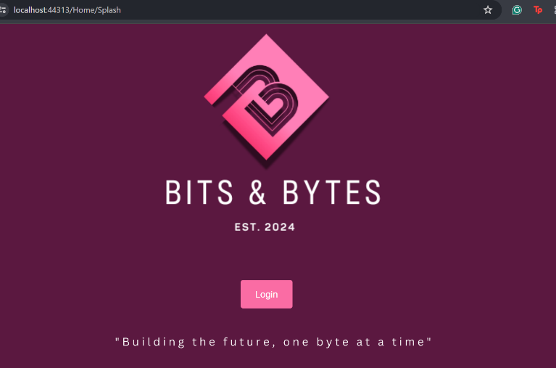Pic 1 Pic 3

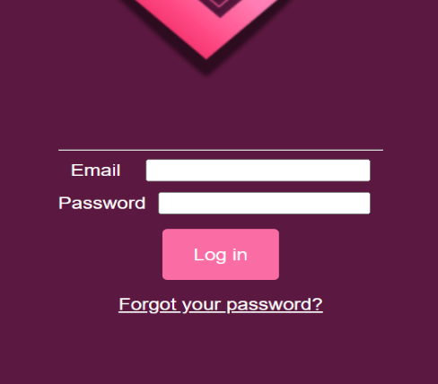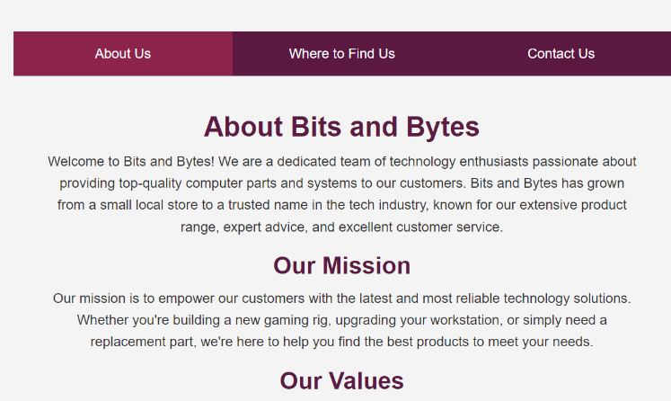 Pic 2

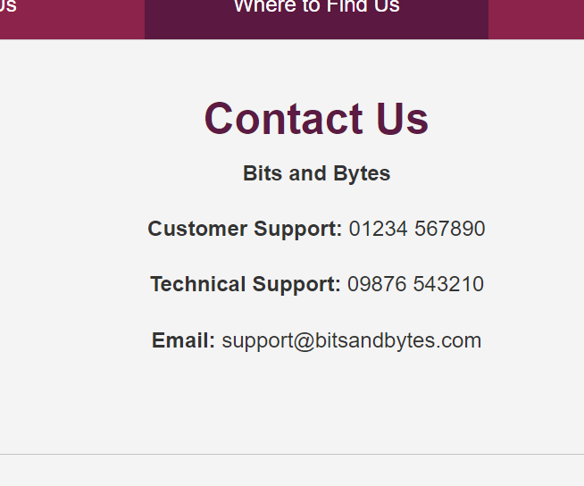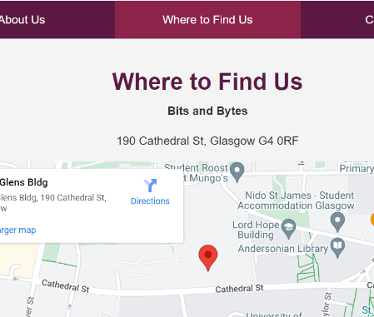PIC 4 .PIC 5

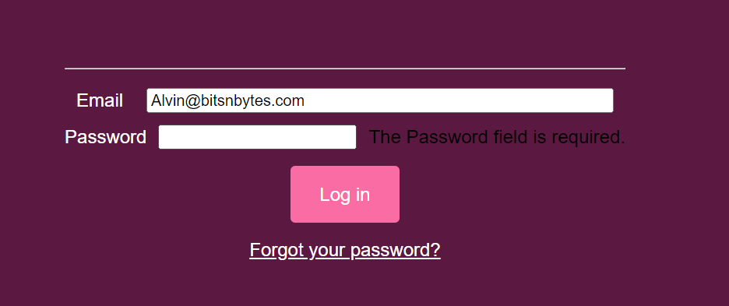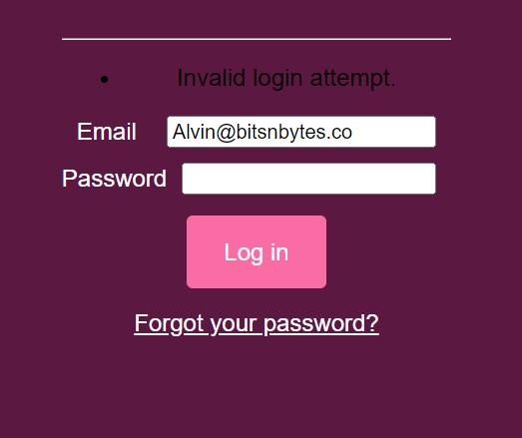 PIC 6 Pic 7

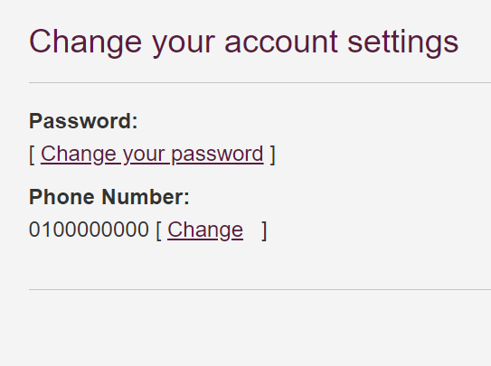Pic 8 pic 9

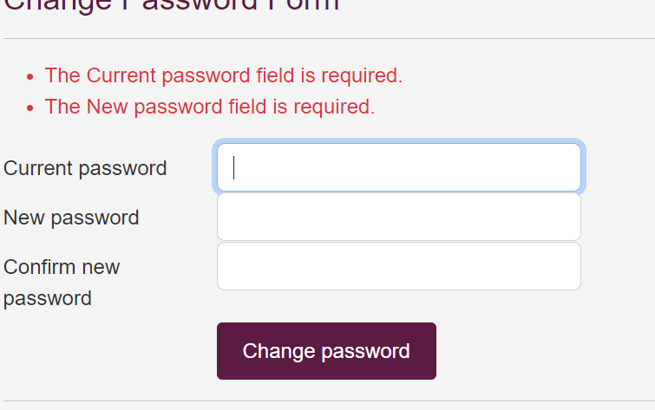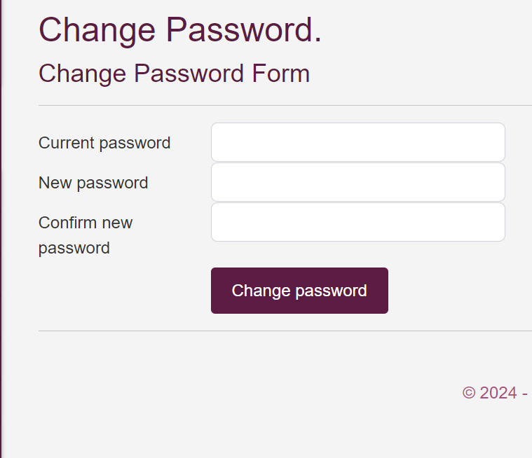Pic 10 Pic 11

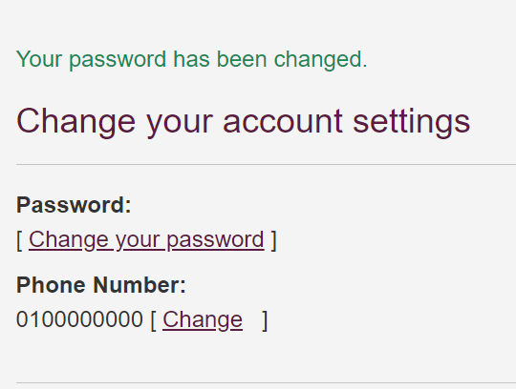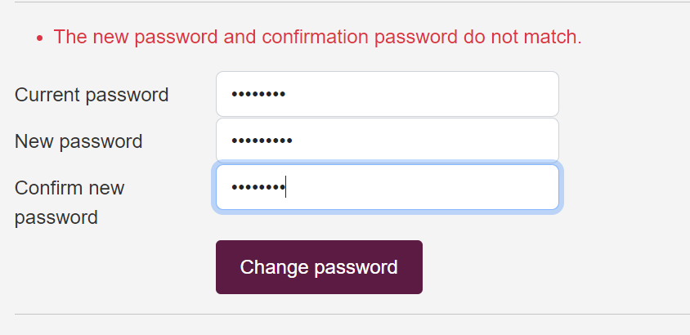Pic 12 Pic 13

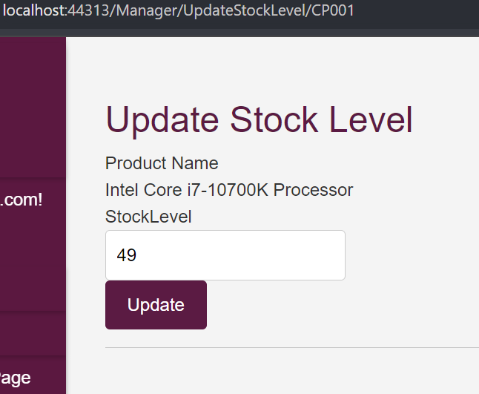

Pic 14 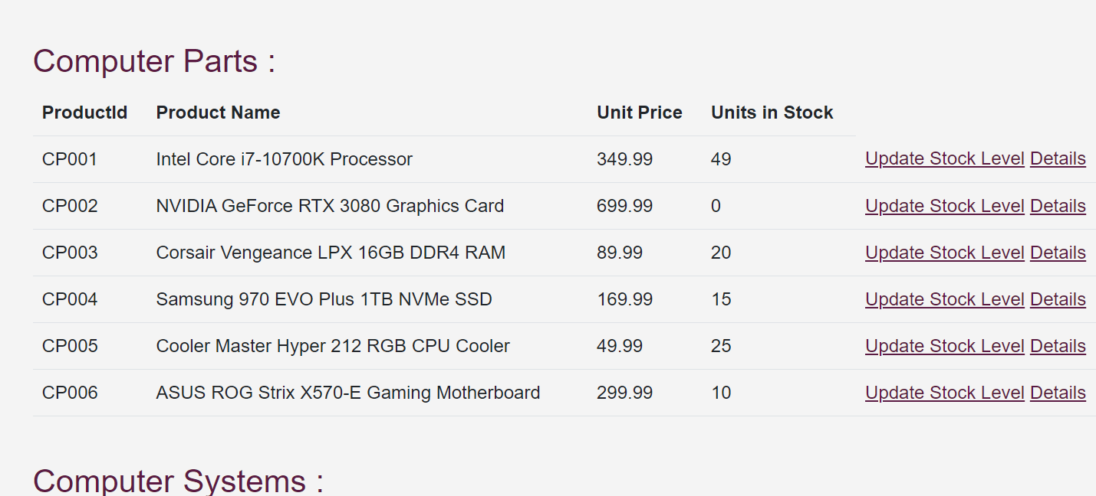Pic 15

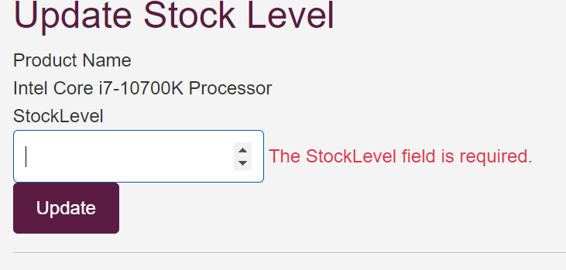Pic 16 Pic 17

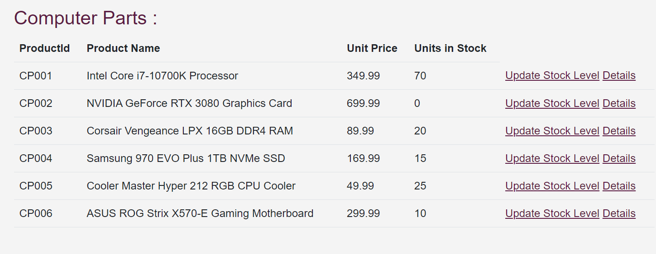

Pic 18

Pic 19

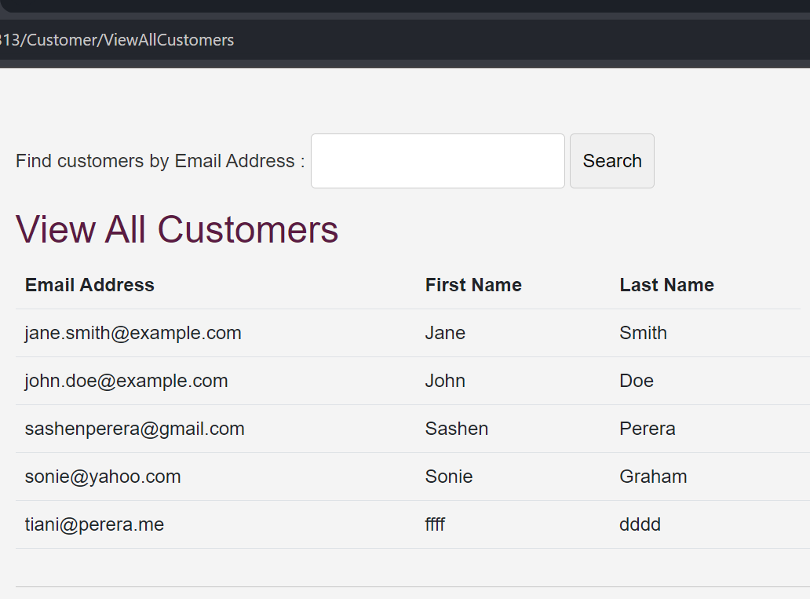Pic 20

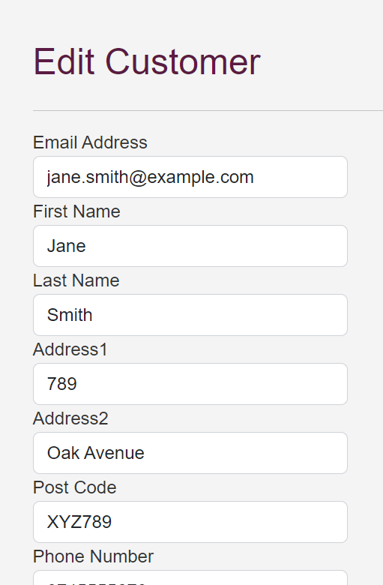Pic 21 Pic 22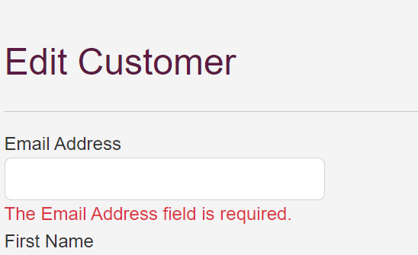

Pic 23



Pic 24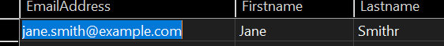

Pic 25

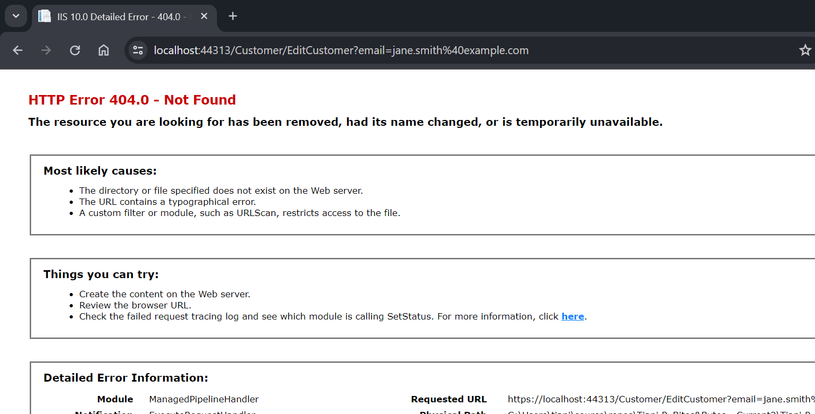Pic 26

Pic 27 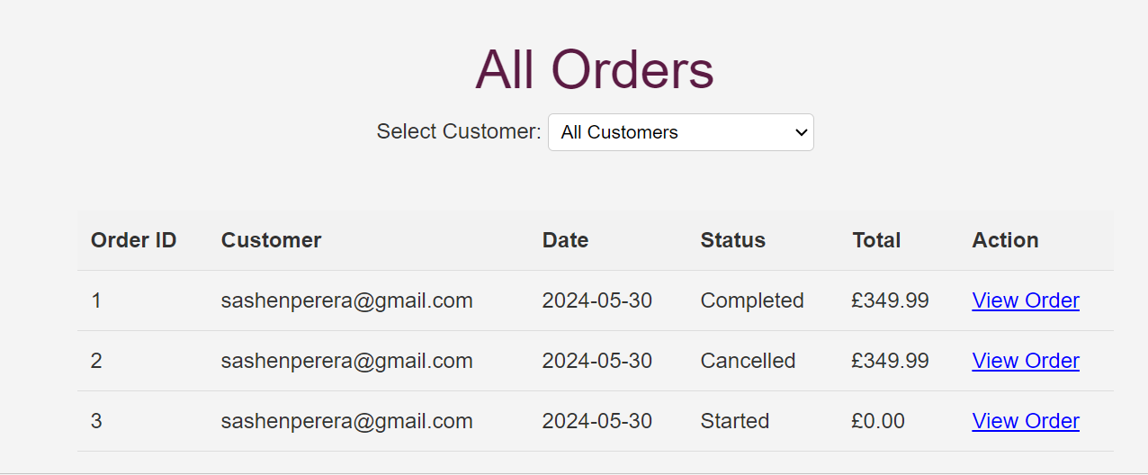

Pic 28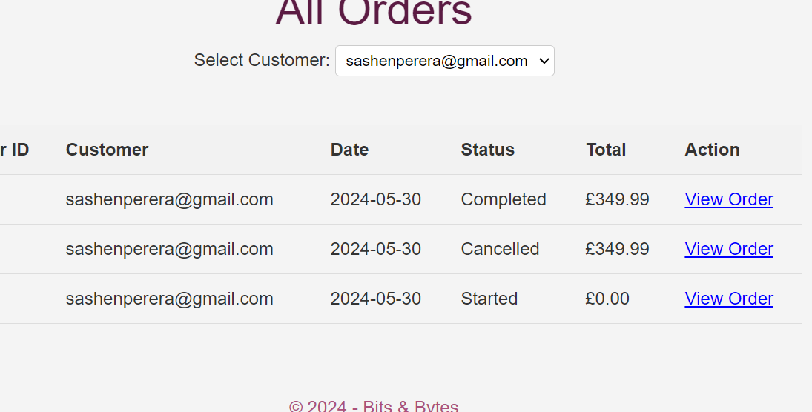

Pic 29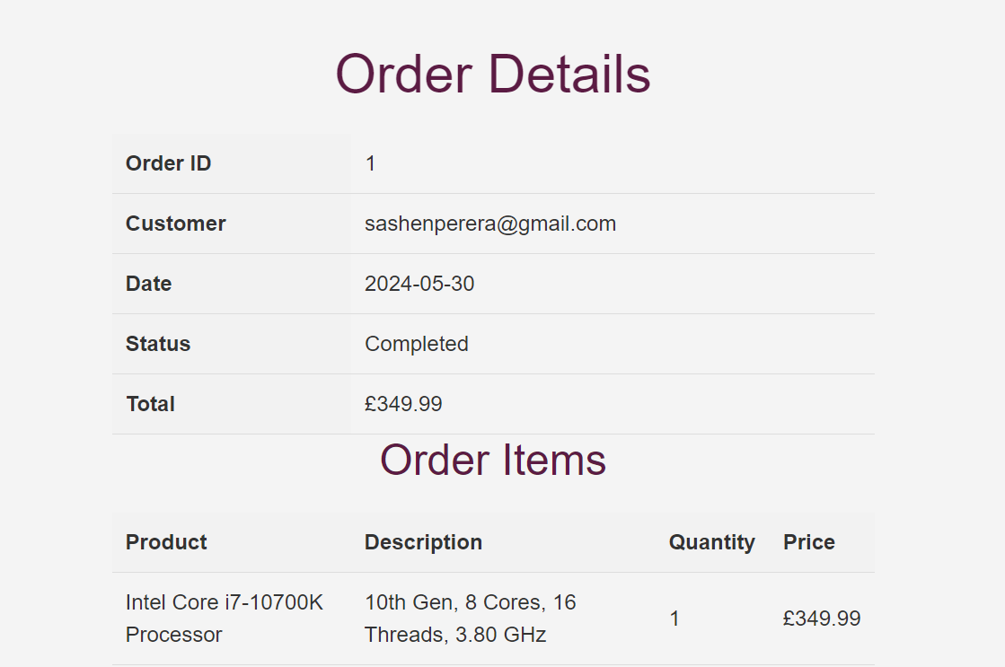

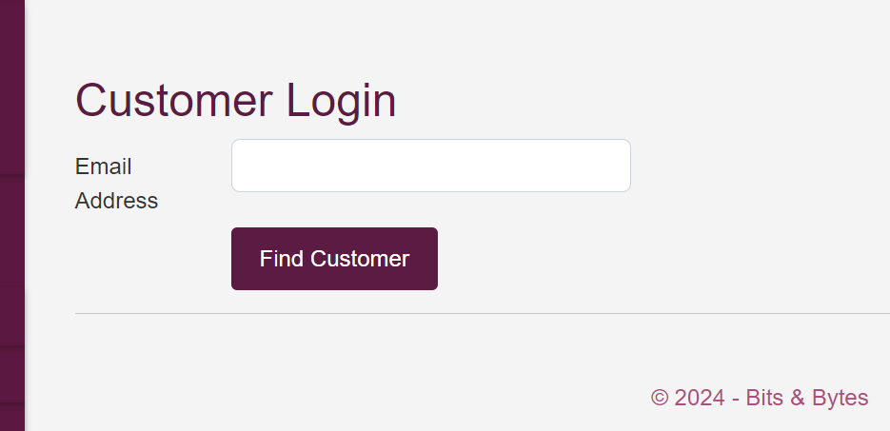Pic 30 Pic 31

Pic 33

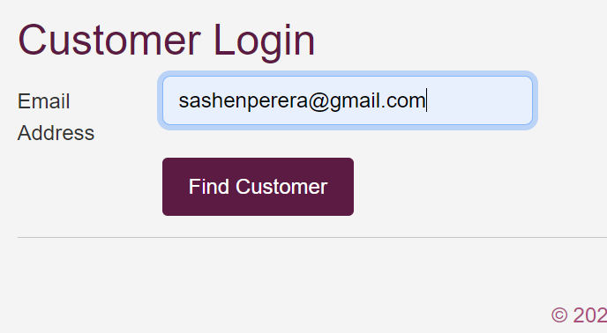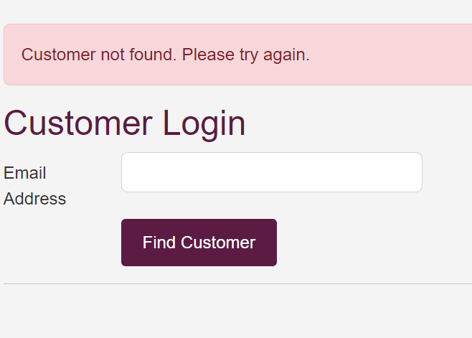Pic 32

Pic 34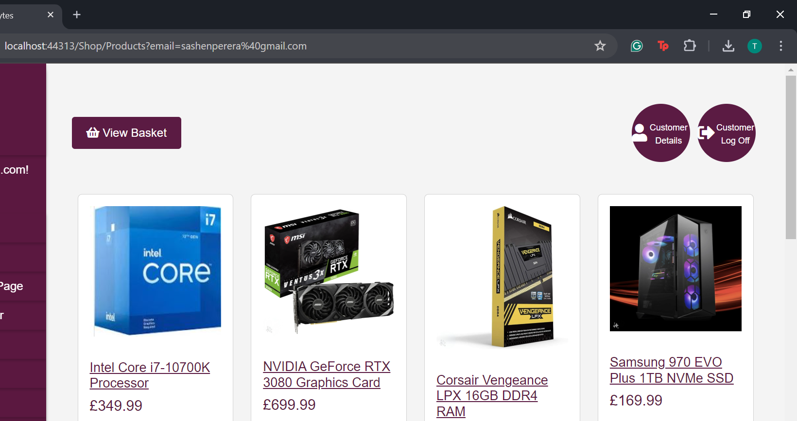

Pic 35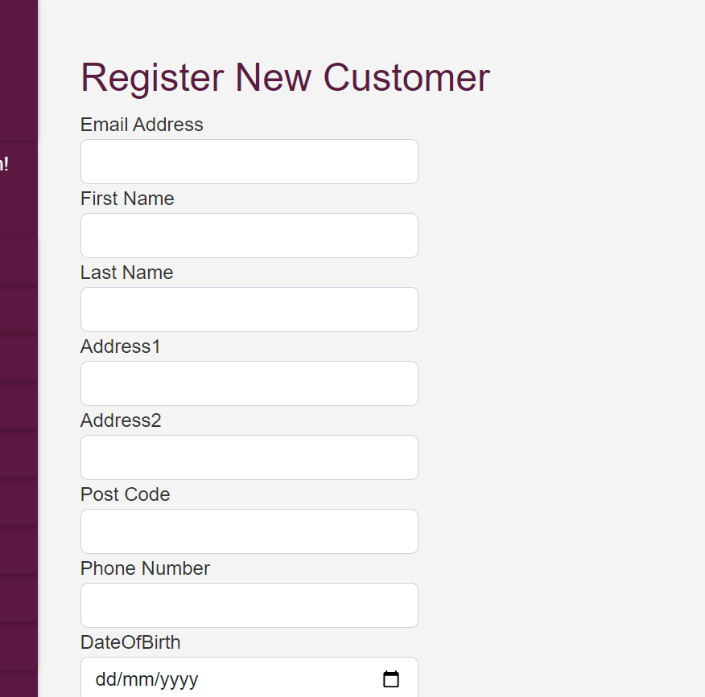

Pic 36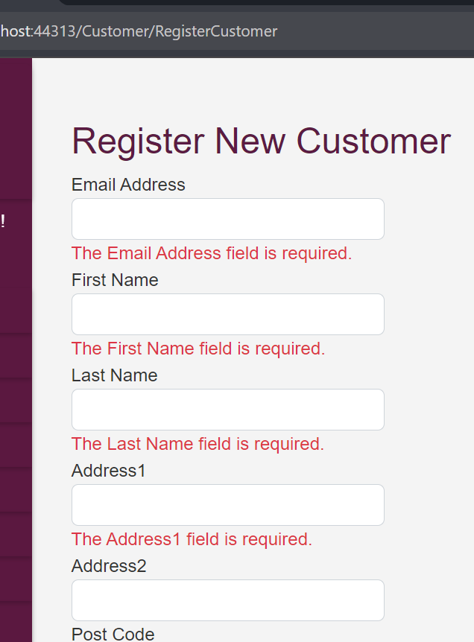

Pic37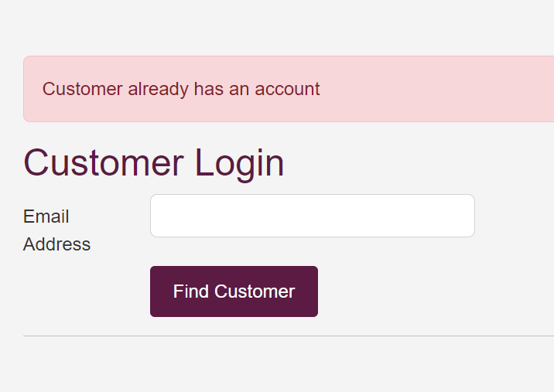

Pic 38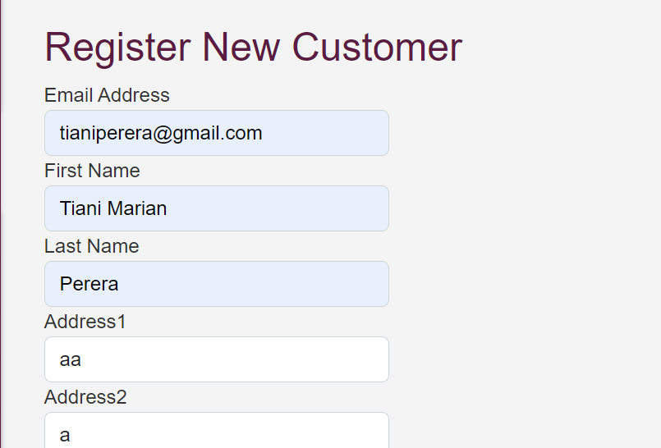

Pic 39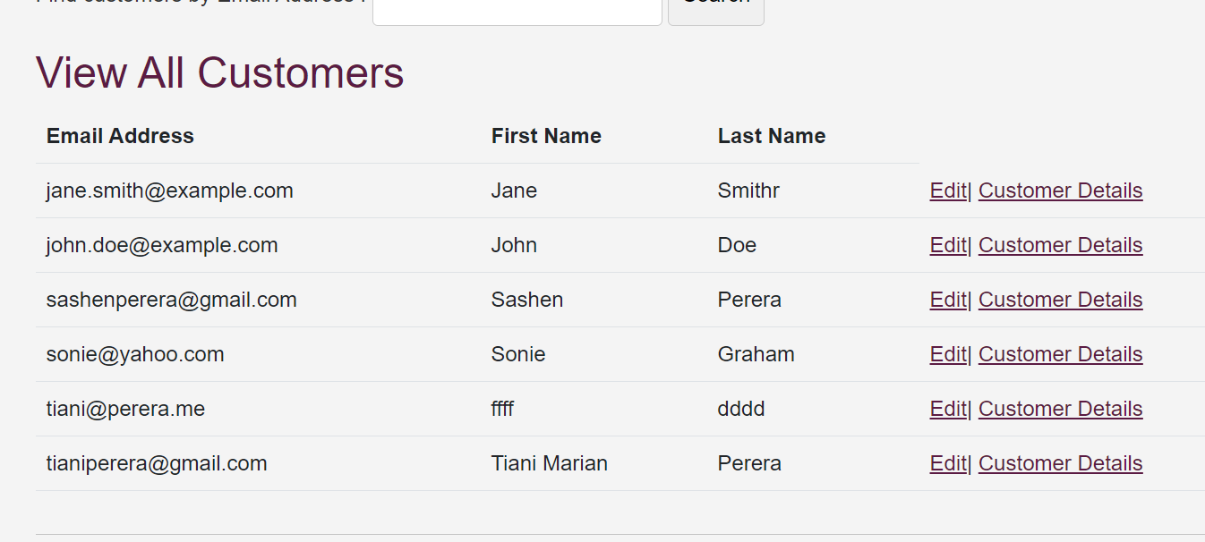

Pic 40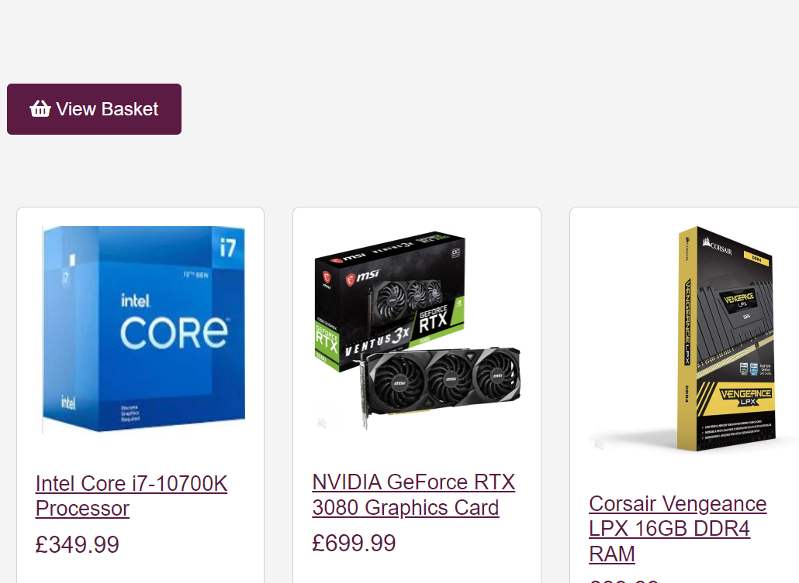

Pic41

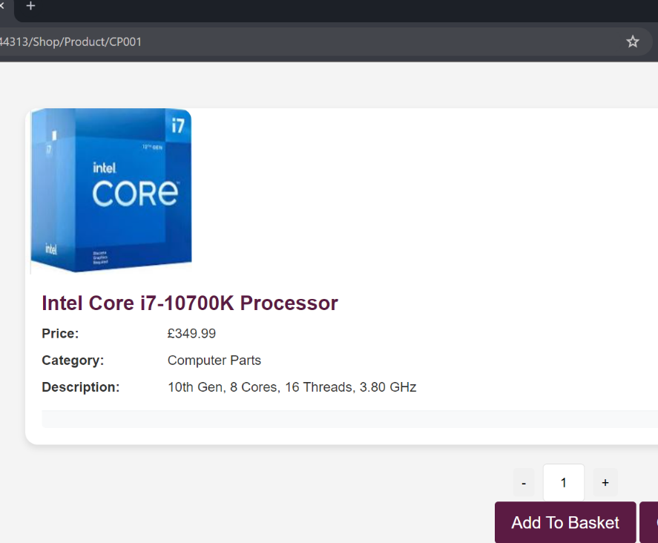Pic 42

Pic 43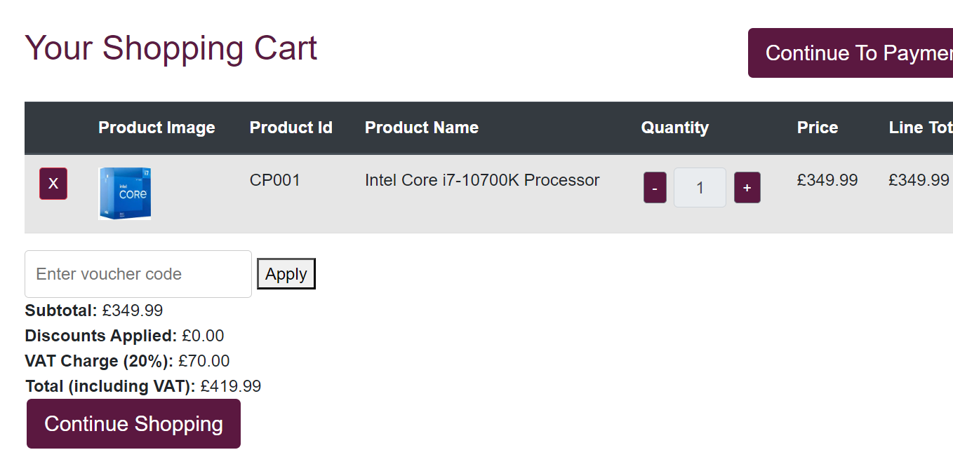Pic 44 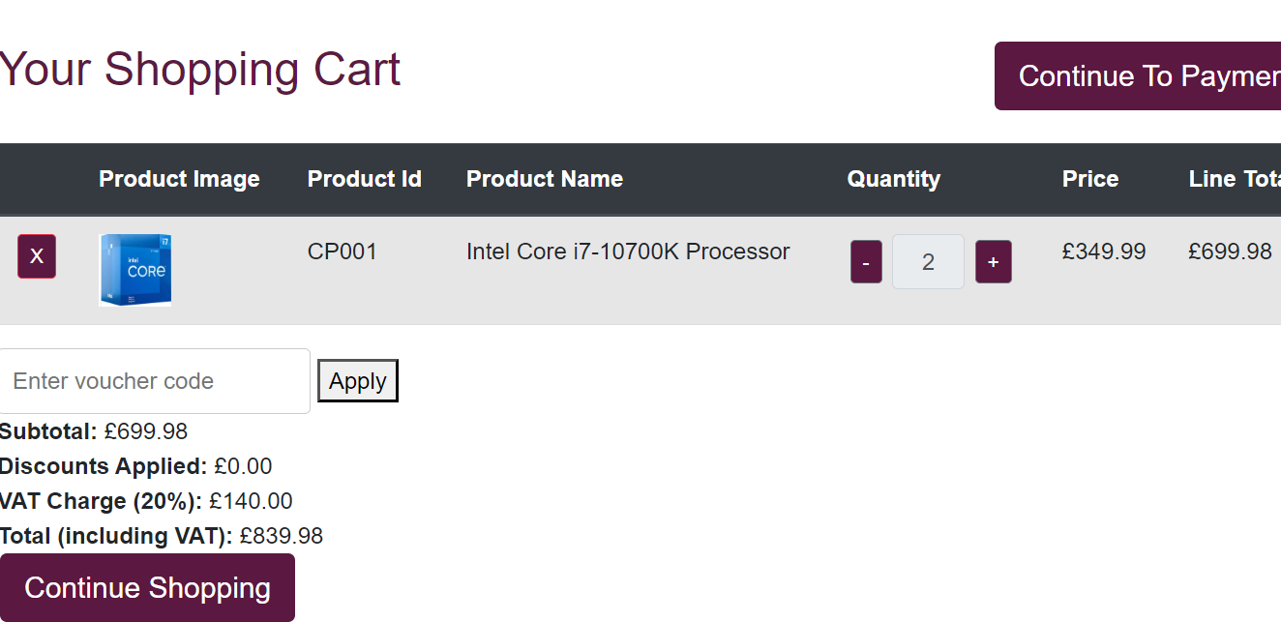

Pic45 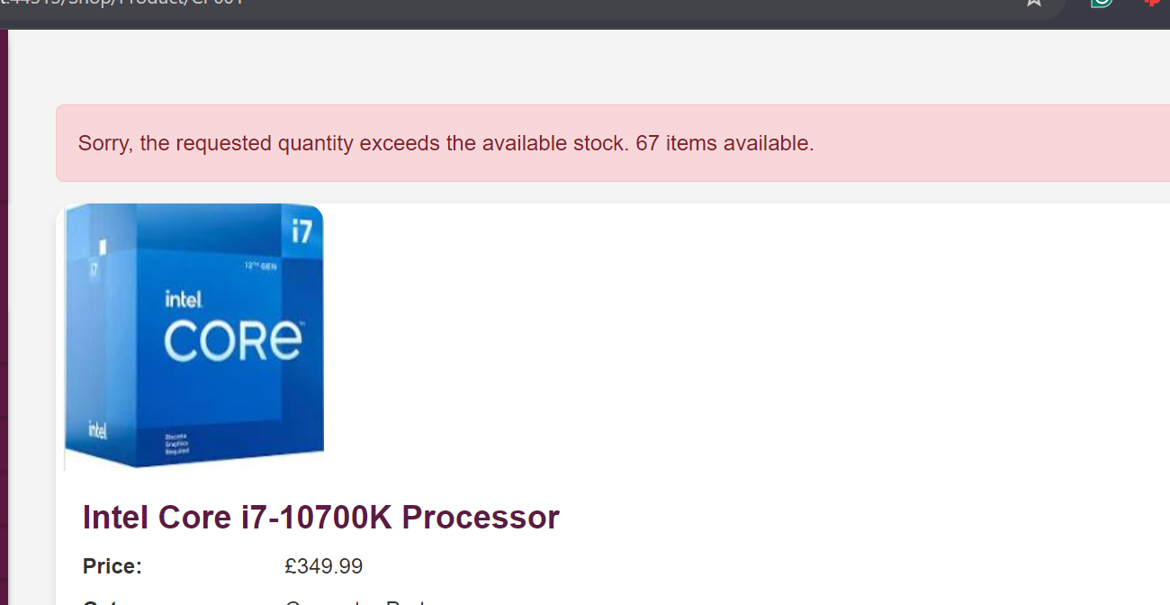

Pic 46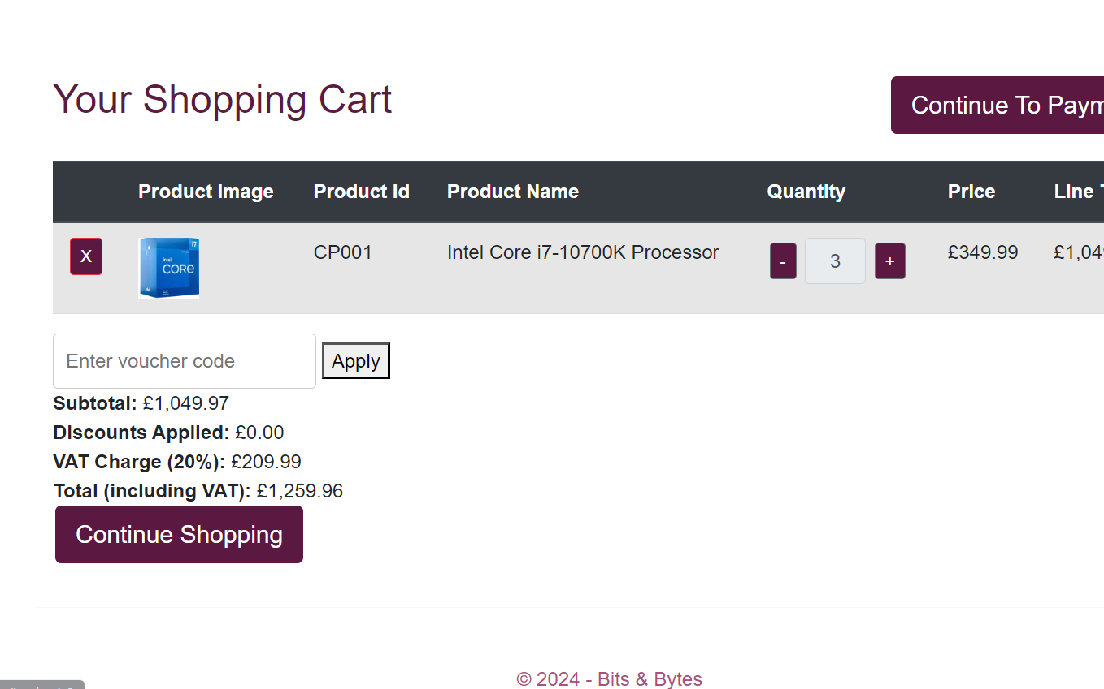

Pic 47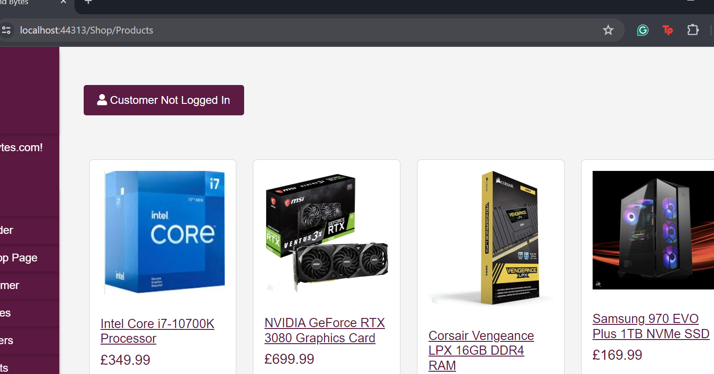

Pic 48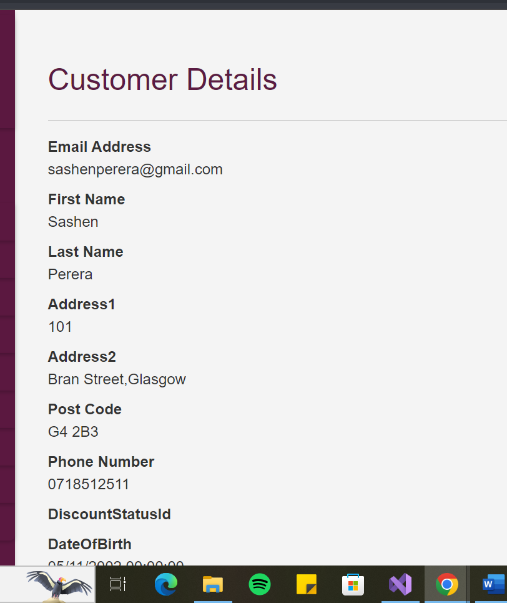

Pic49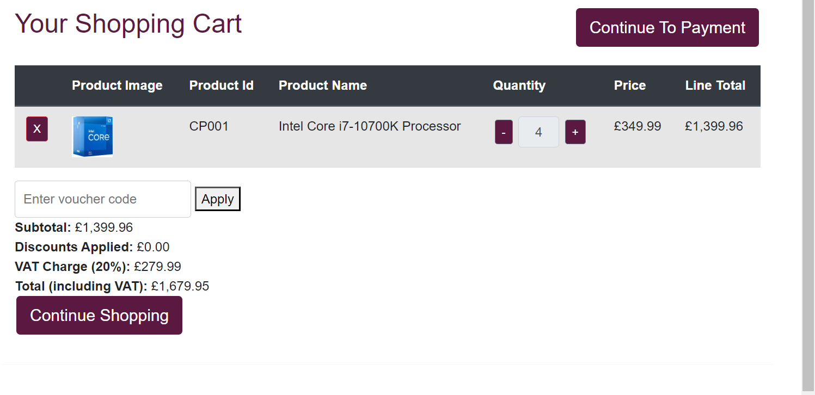

Pic50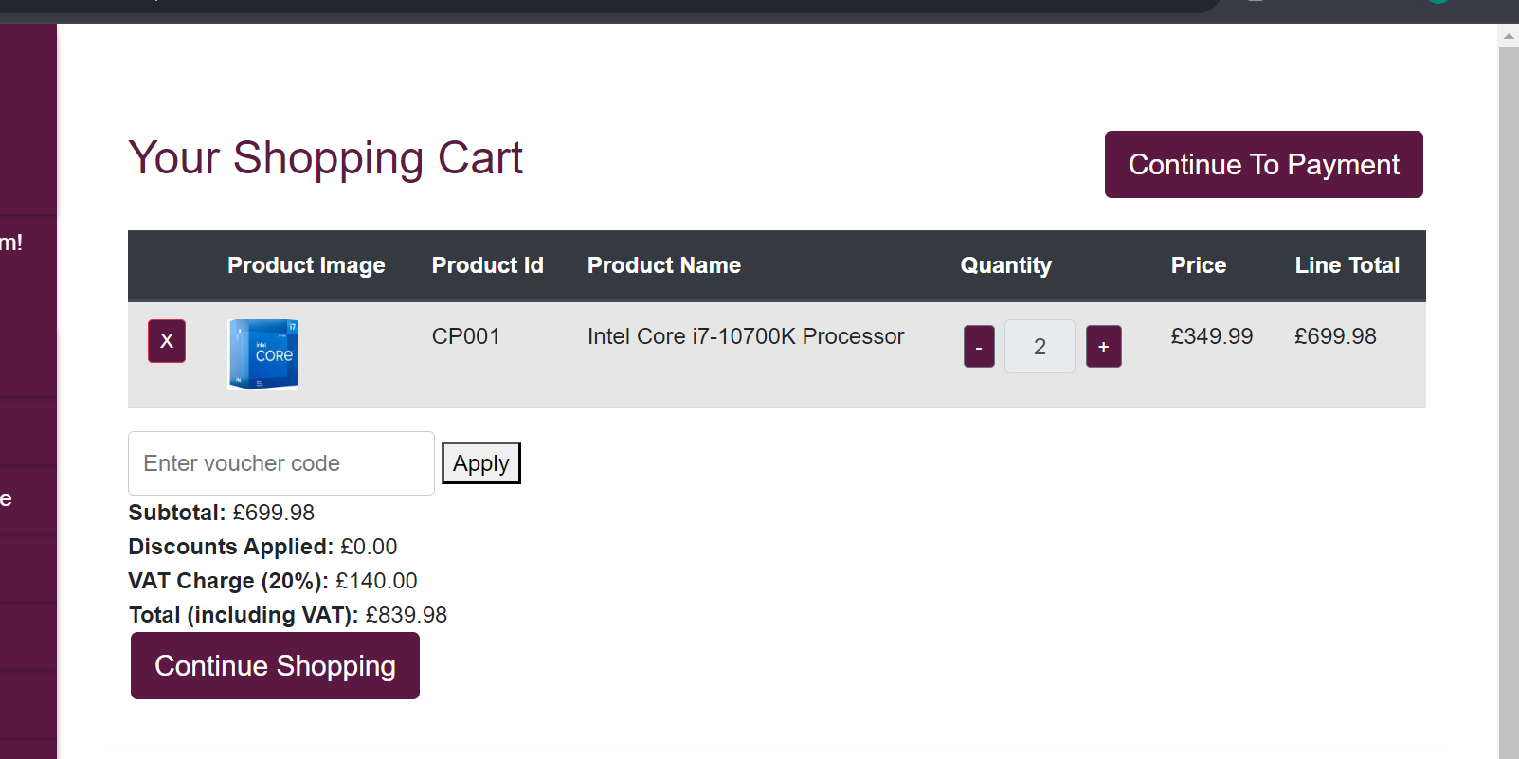

Pic51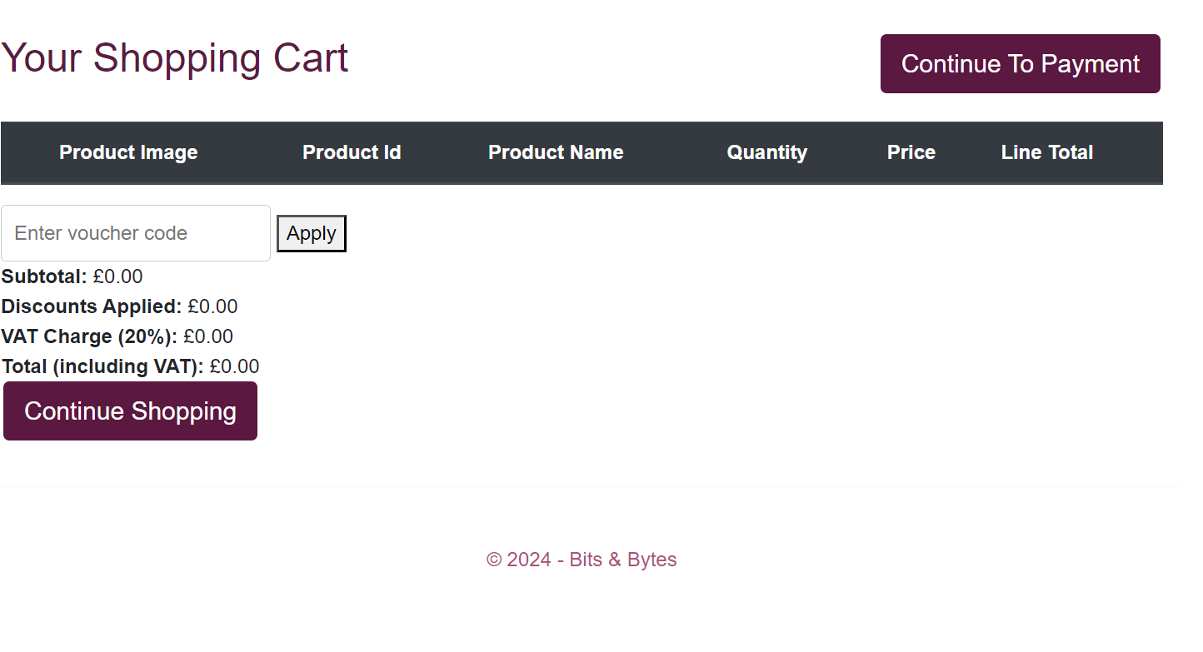

Pic 52 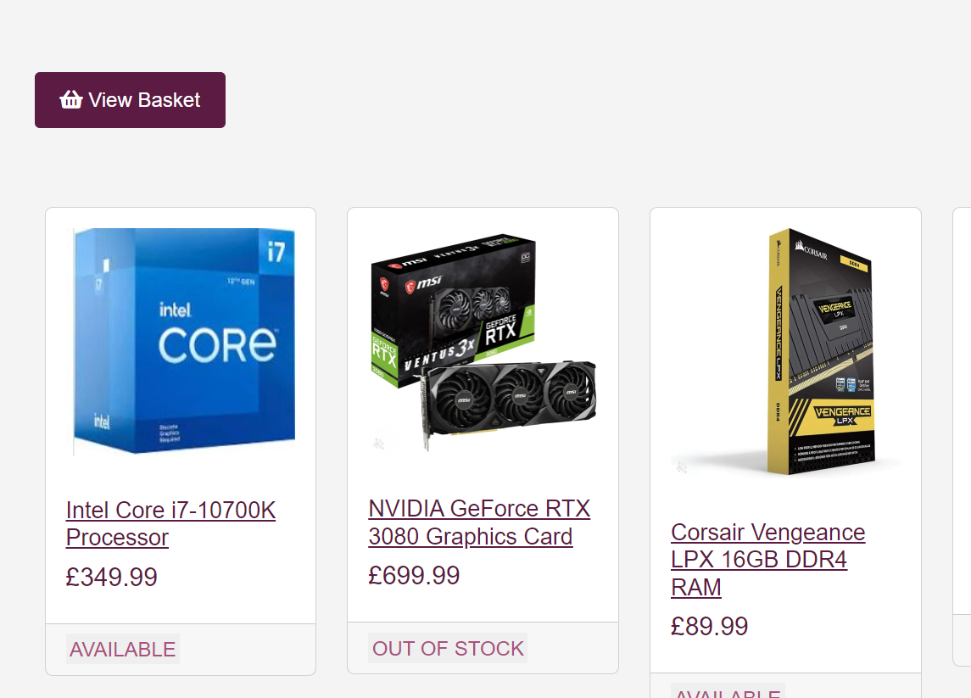

Pic 53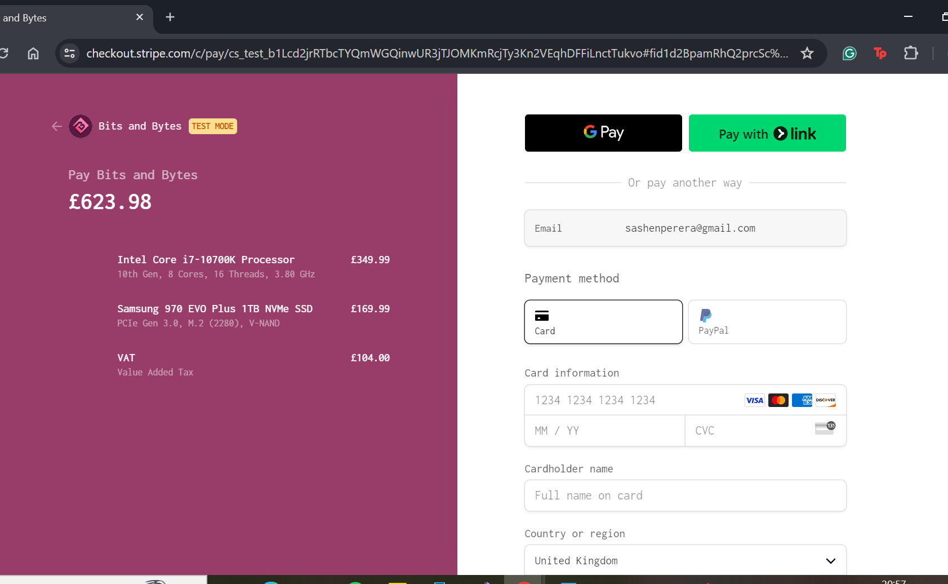

Pic54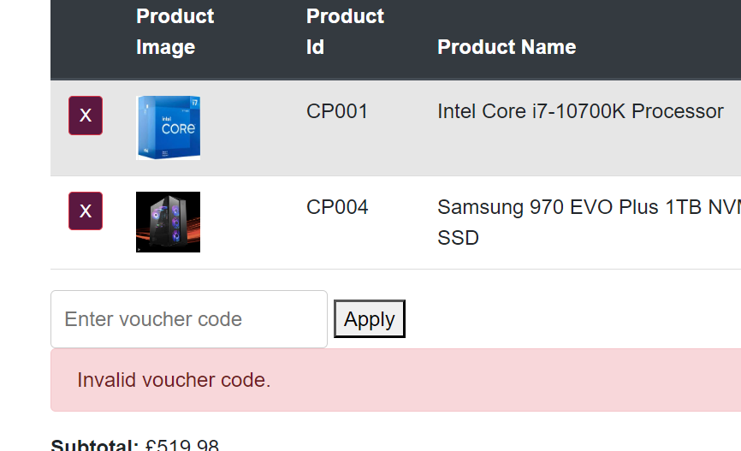

Pic55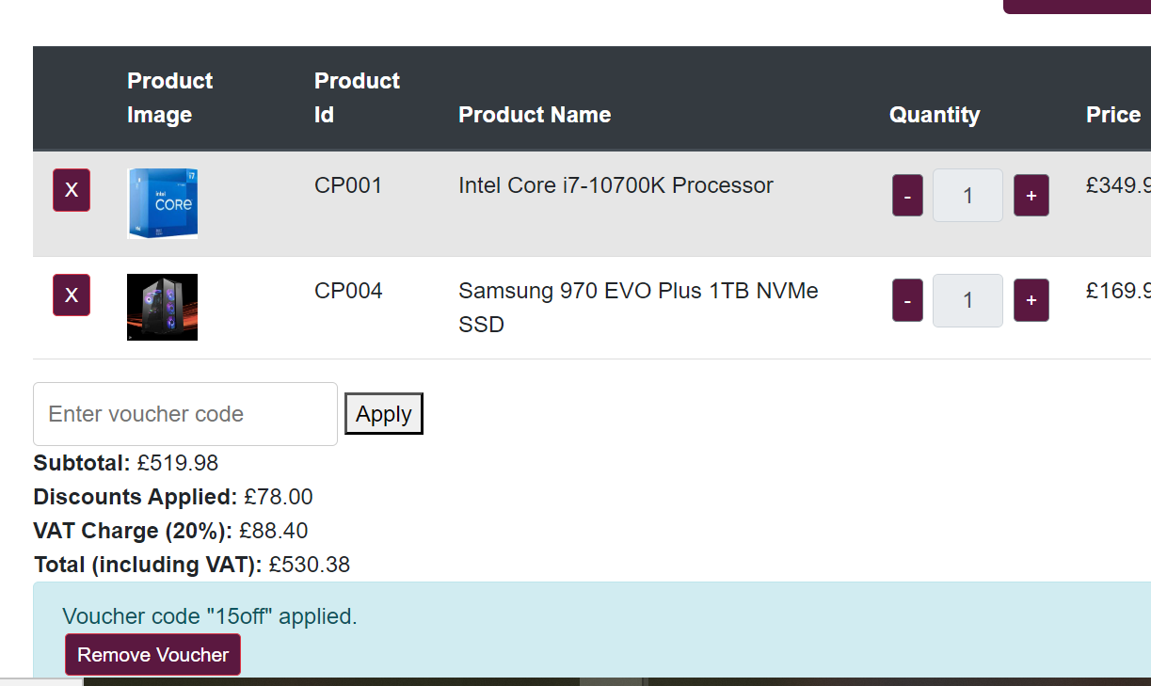

Pic 56

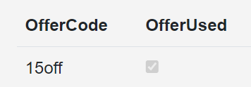

Pic 57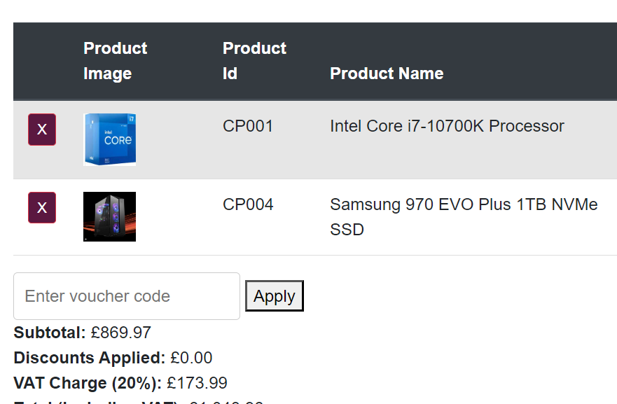

Pic 58 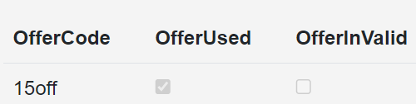

Pic 59 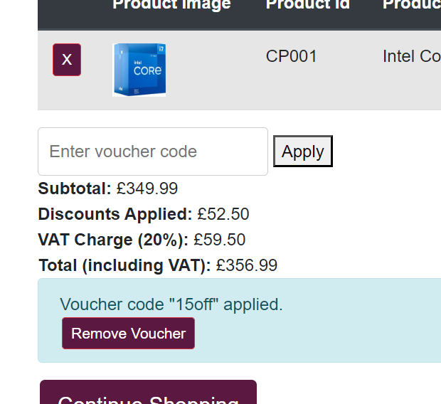

Pic 60 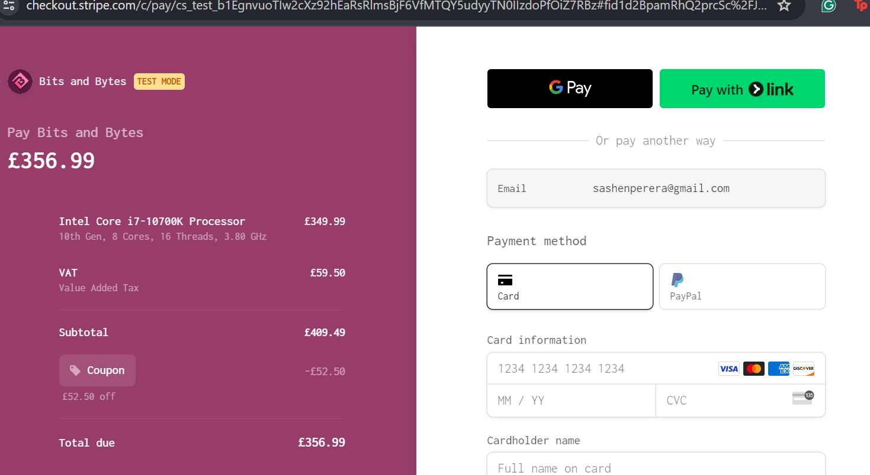

Pic 61 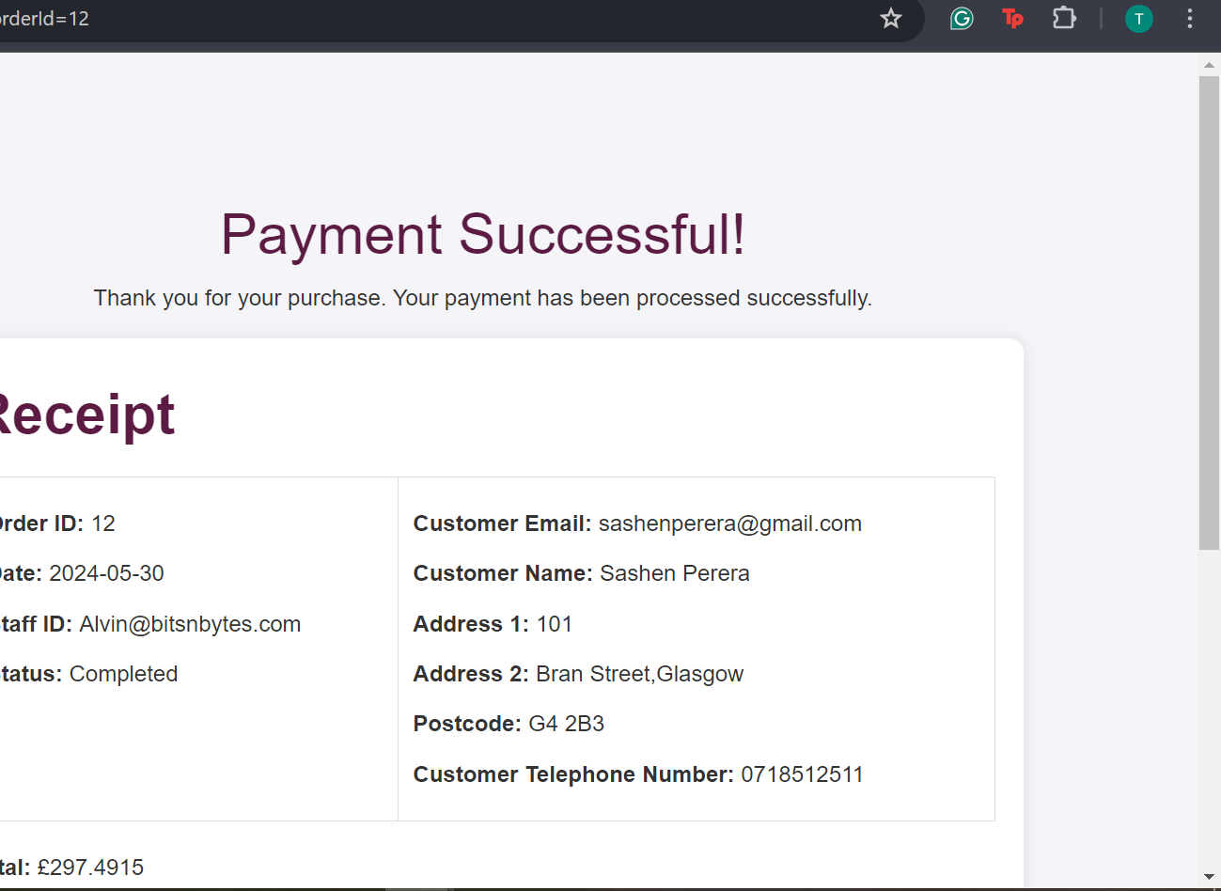

Pic 62 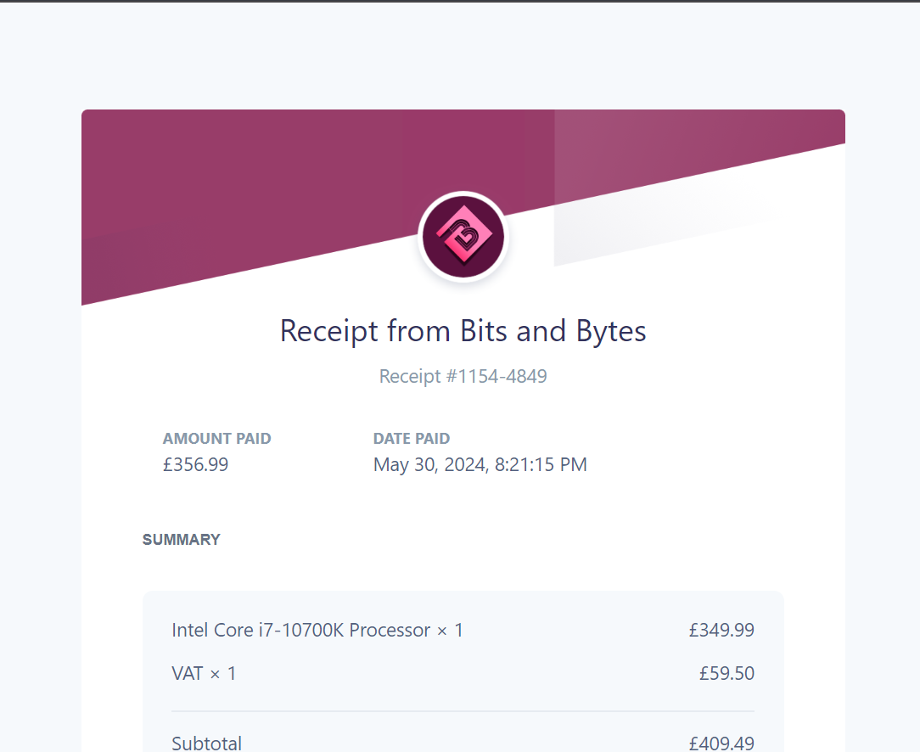

Pic 63 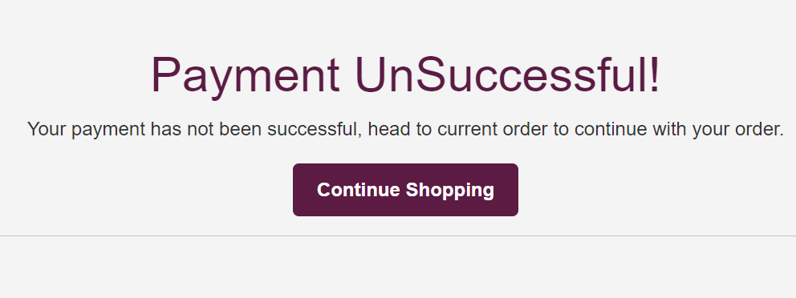

Pic 64 

Pic 65 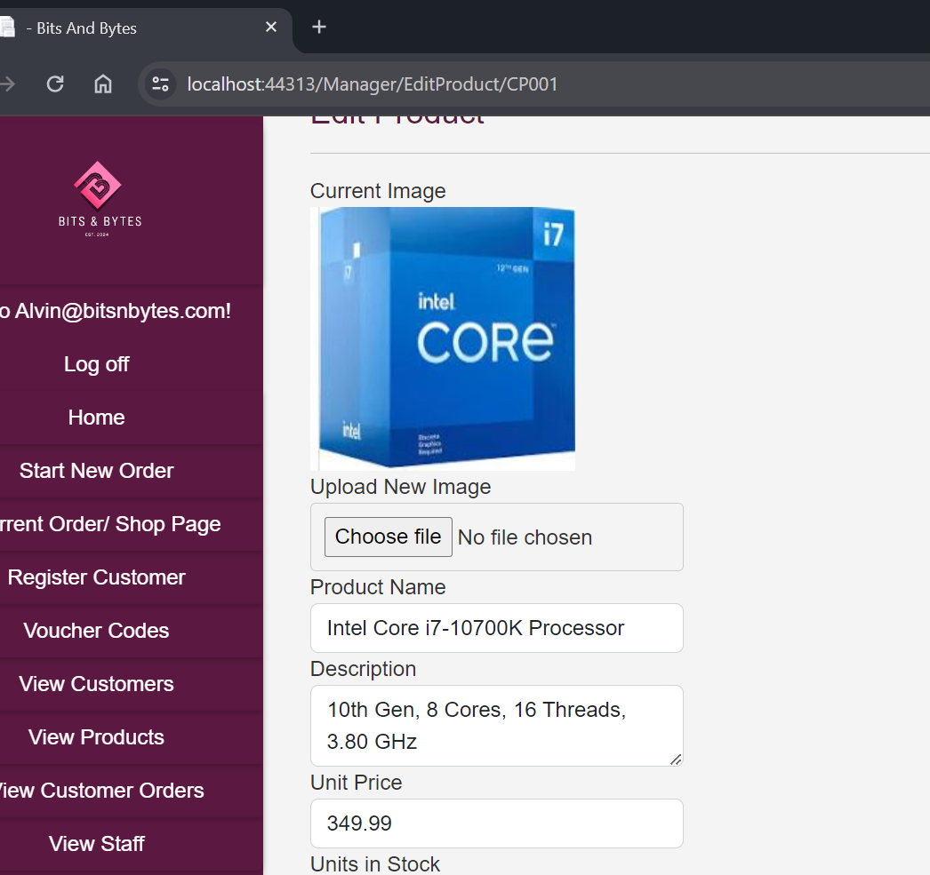

Pic 66 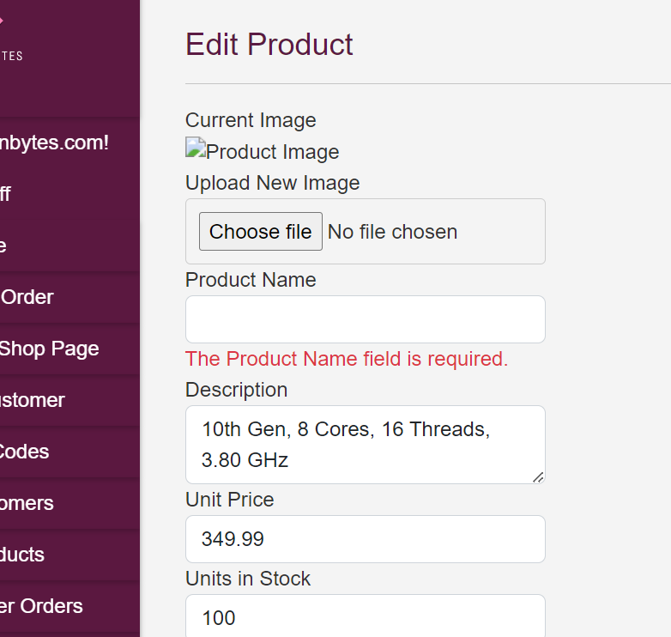

Pi c 67 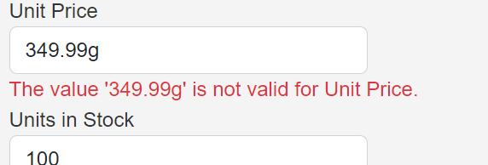

Pic 68 

Pic 69 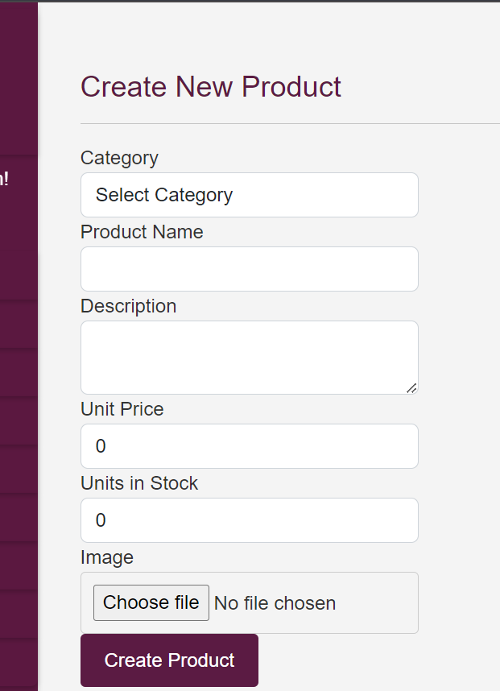

Pic70 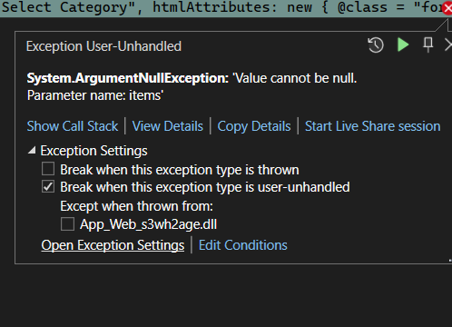

Pic 71 

Pic 72 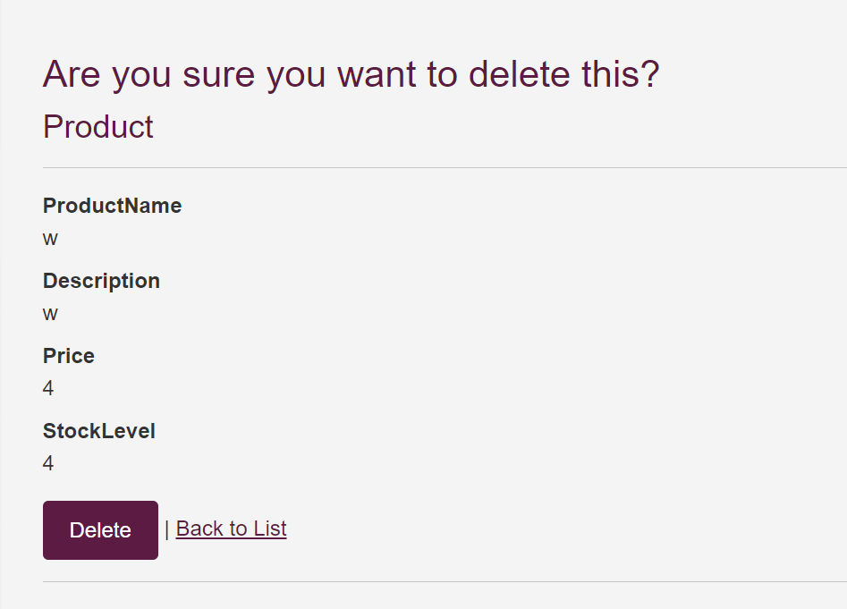

Pic 73 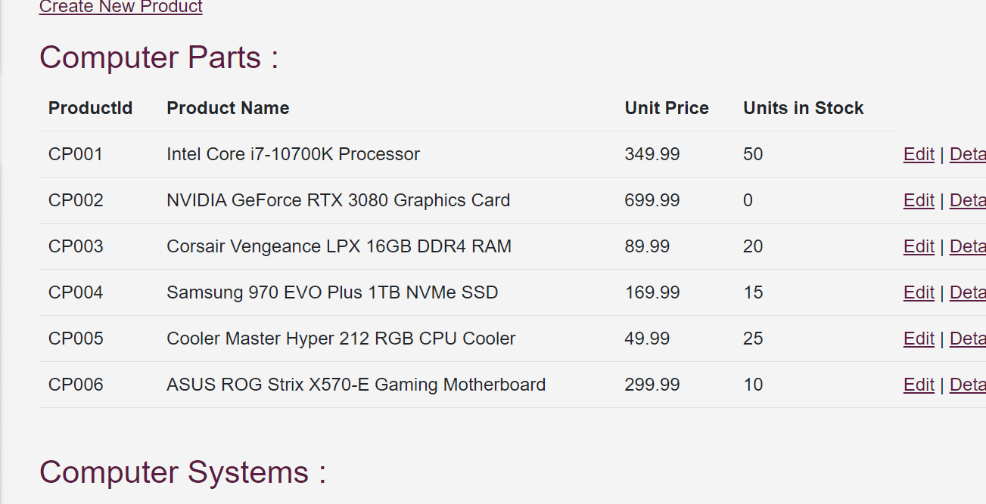

Pic 74 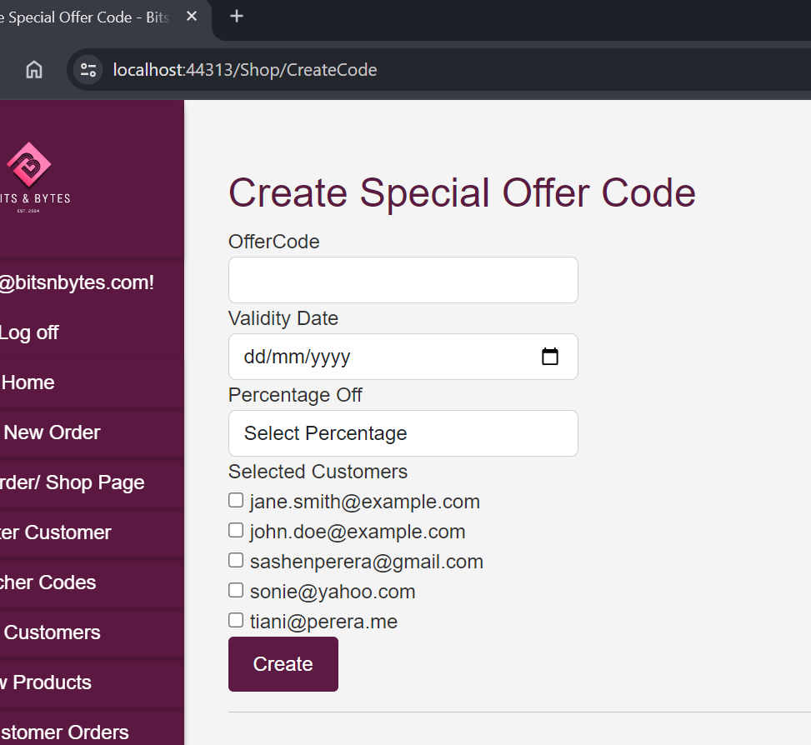

Pic 75 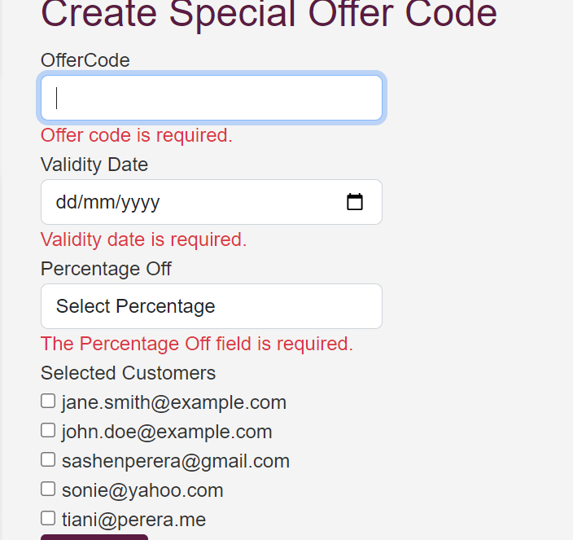

Pic 76 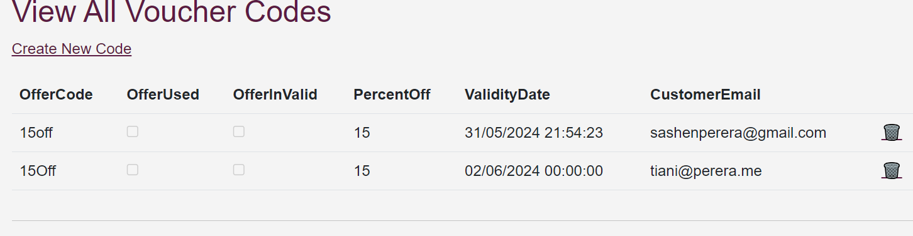

Pic 77 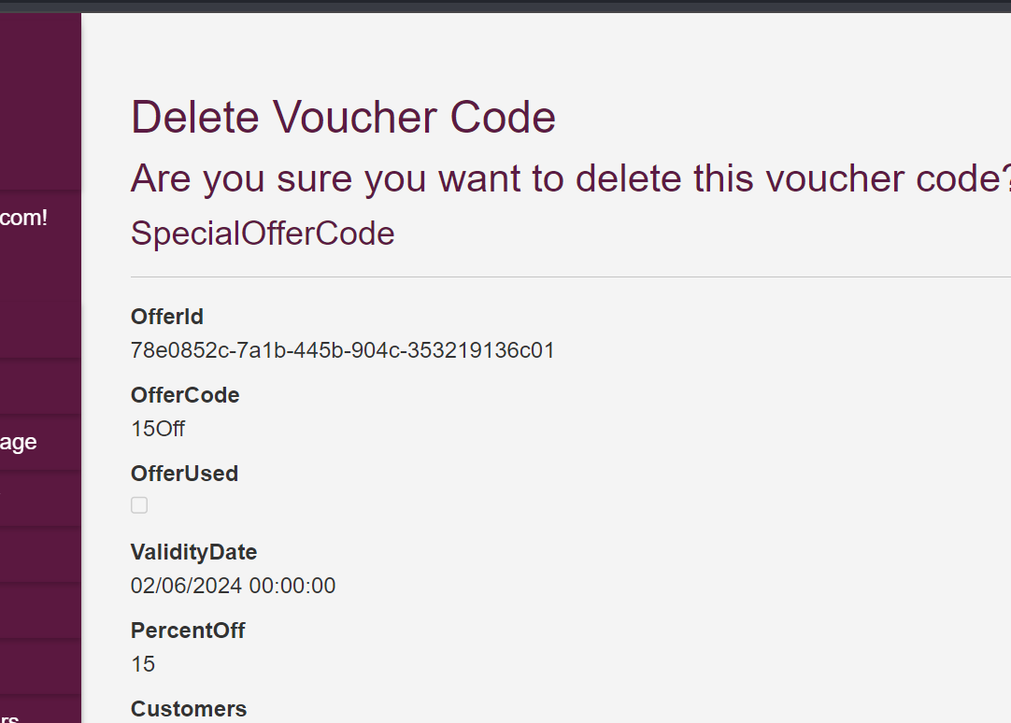pic 78 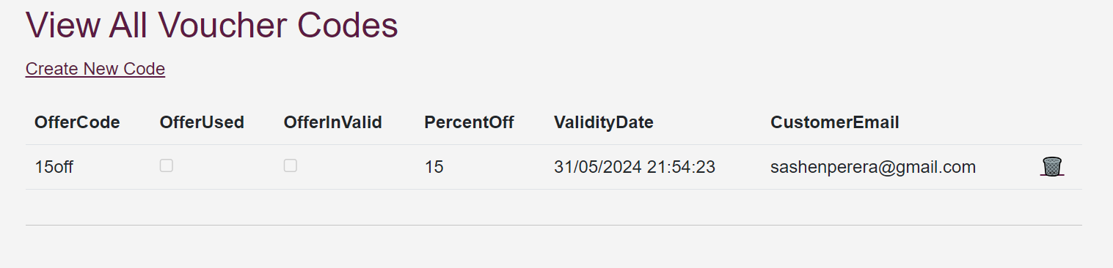

Pic 79 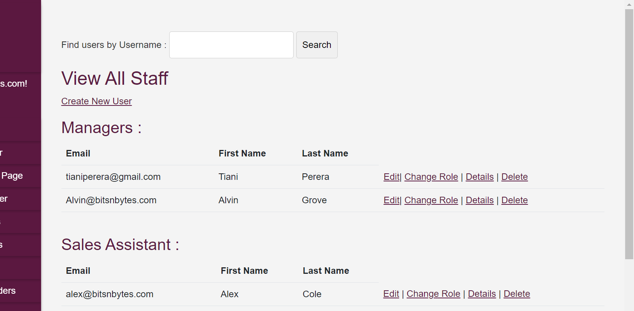

Pic 80 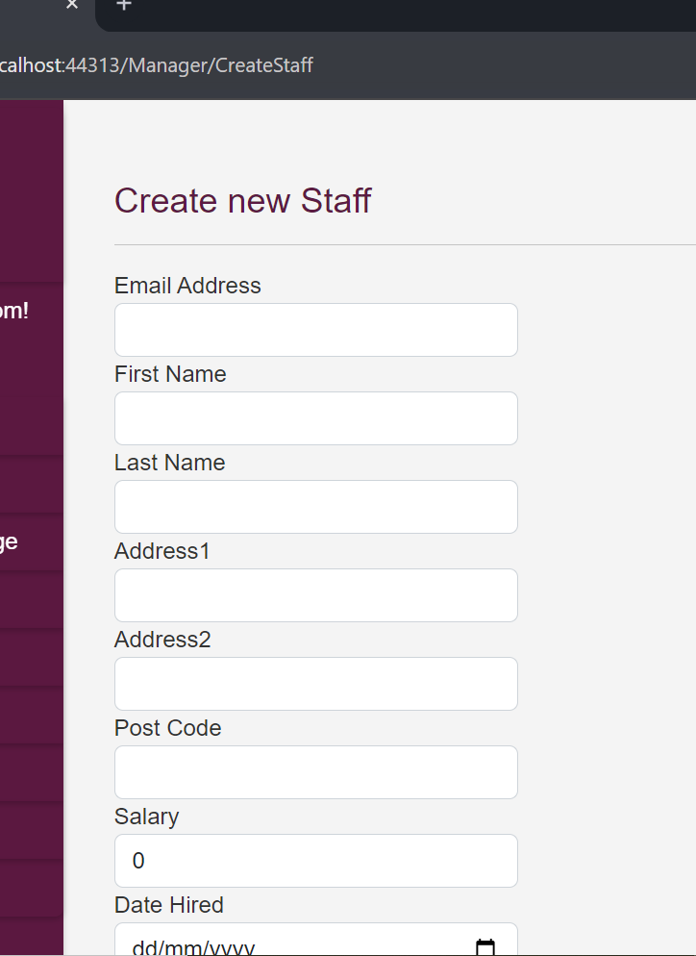

Pic 81 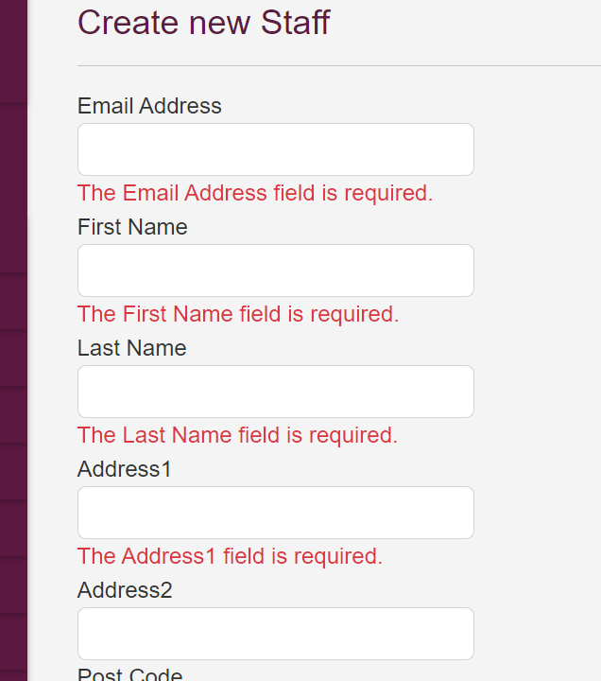

Pic 82 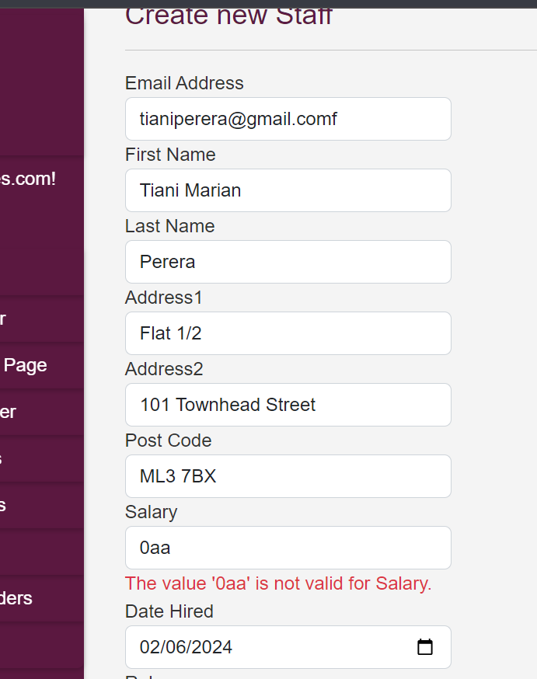

Pic 83

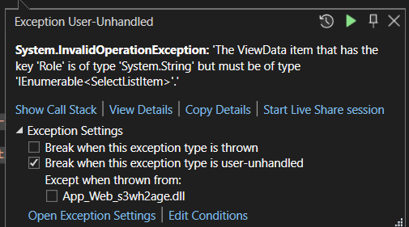

Pic 84 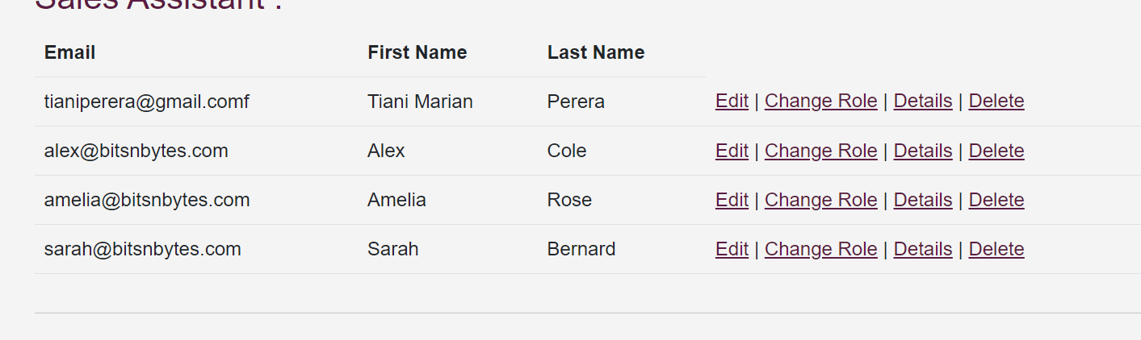Pic 85 

Pic86 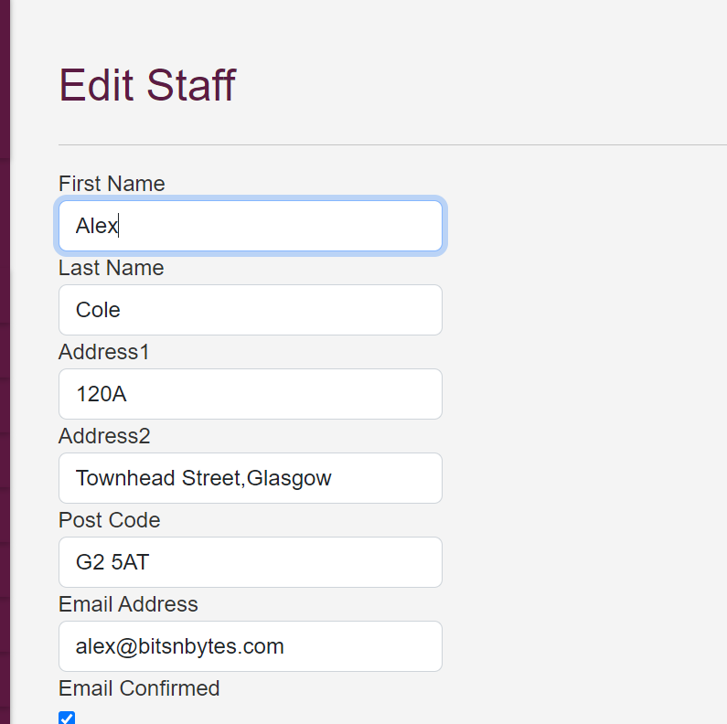

Pic87 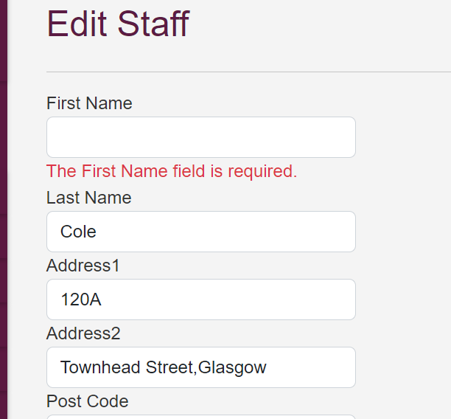

Pic 88

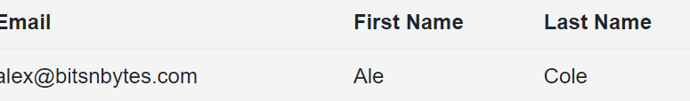

Pic 89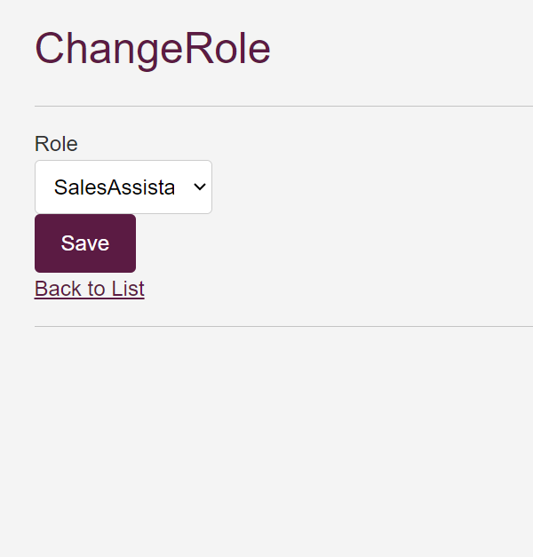

Pic 90

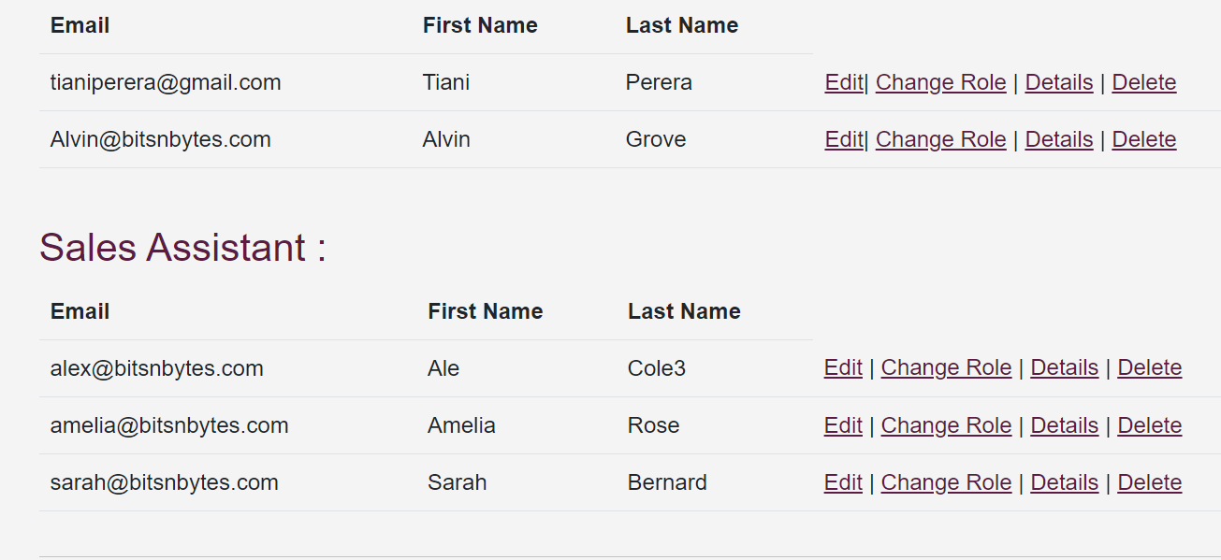

Pic 91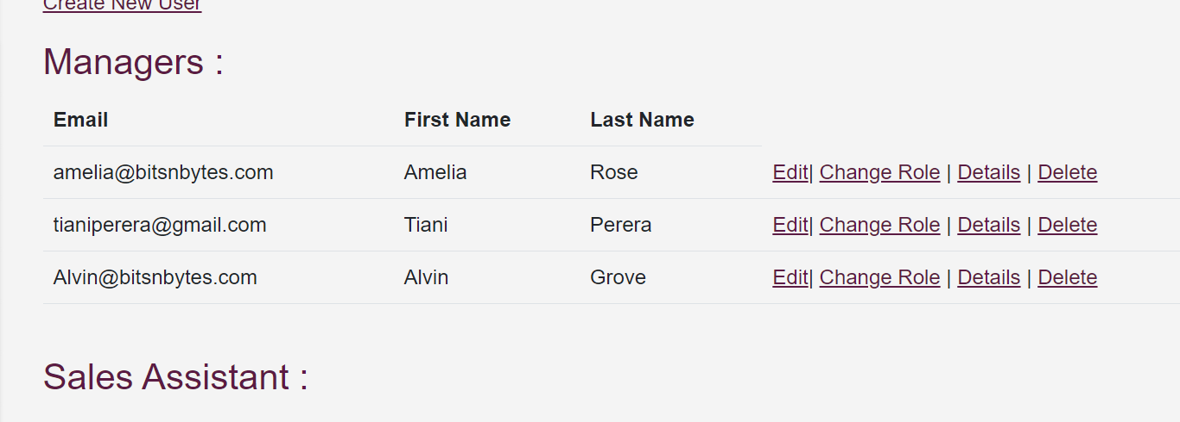

Pic 92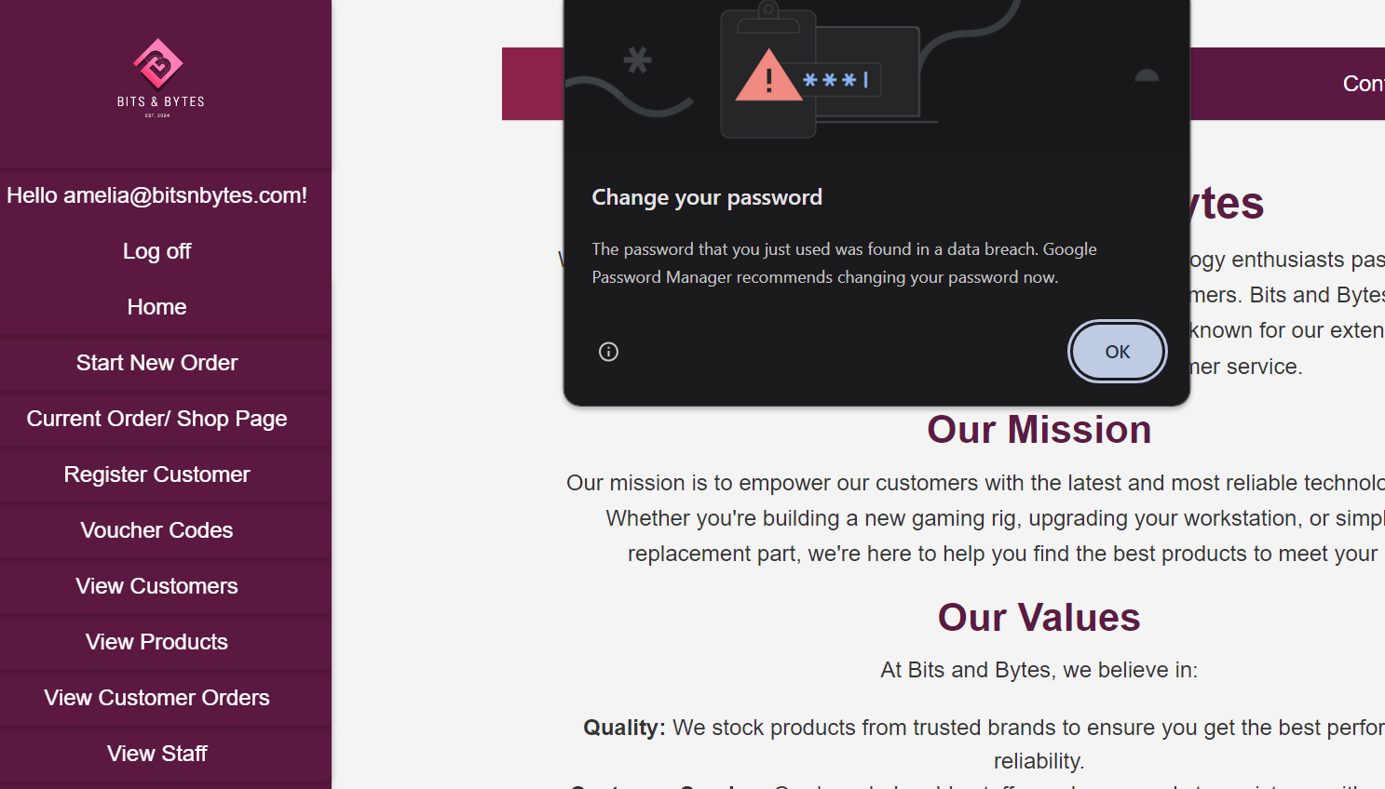

Pic93

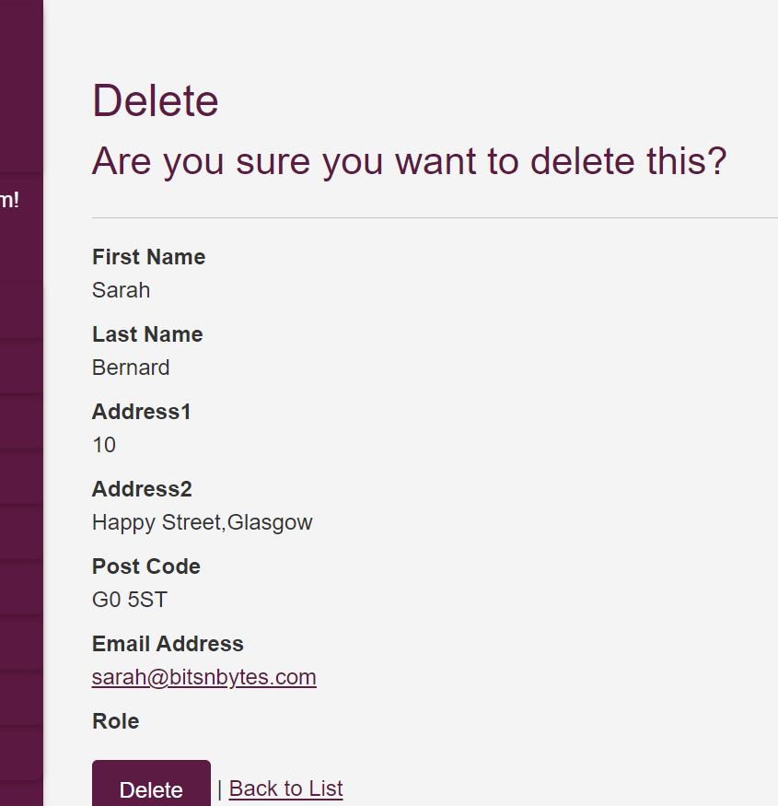

Pic 94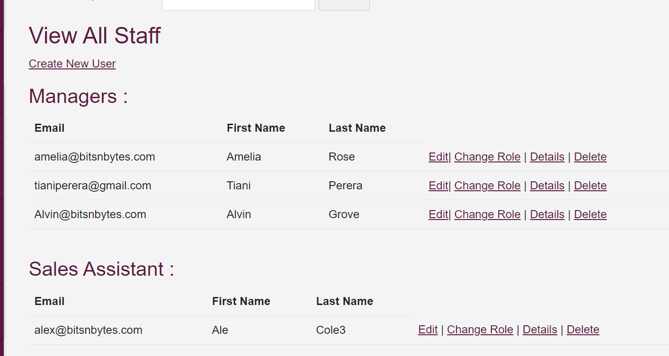

Pic95 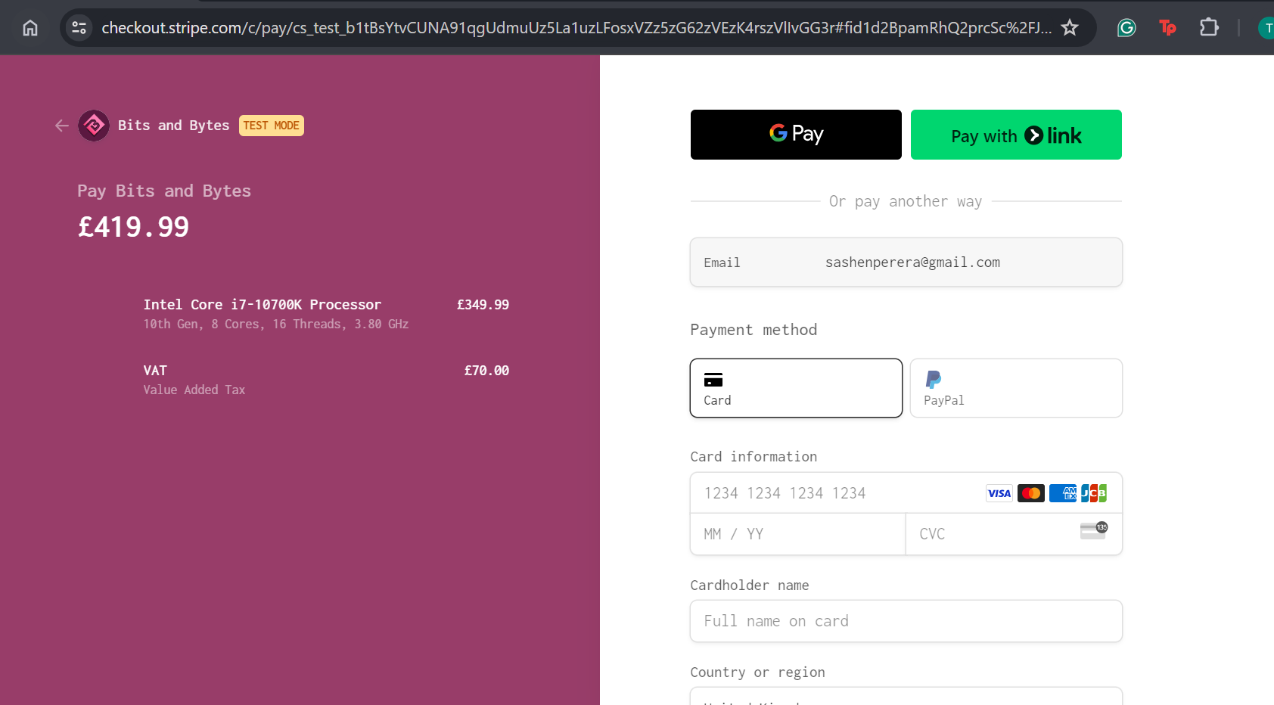

Pic 96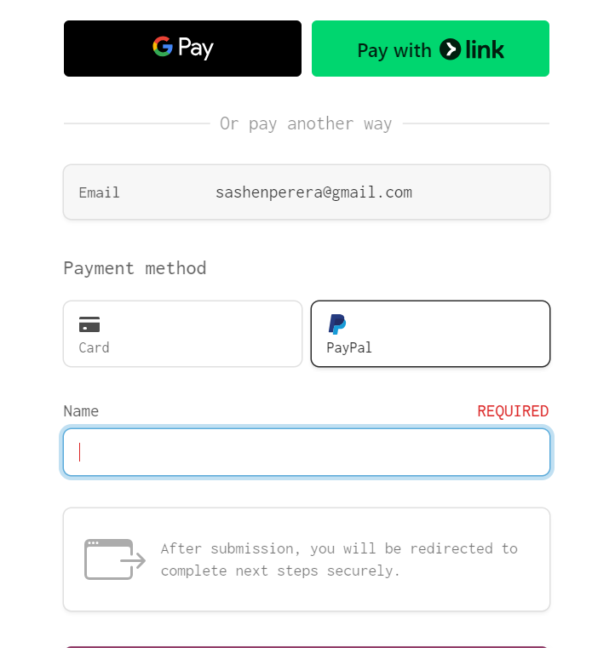

Pic 97 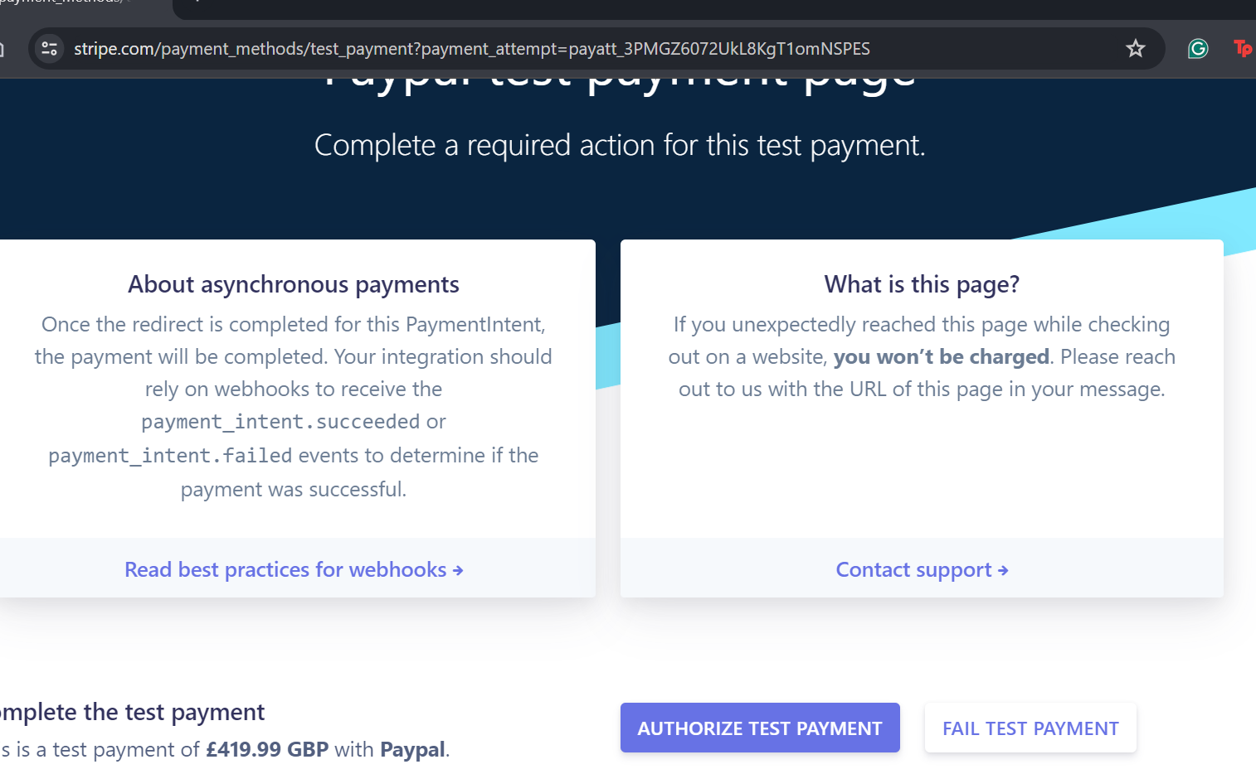

Pic 98

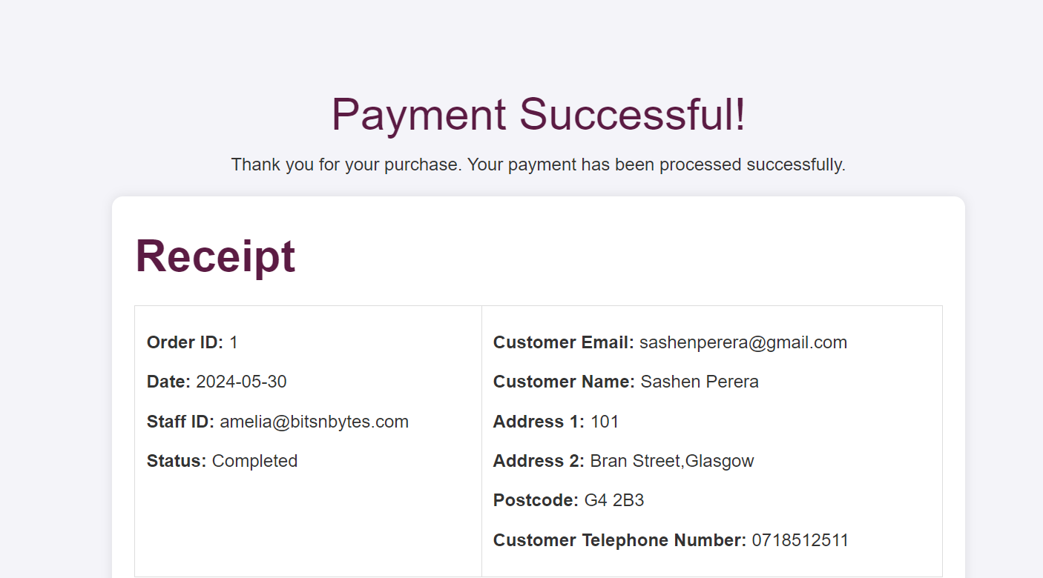

Pic 99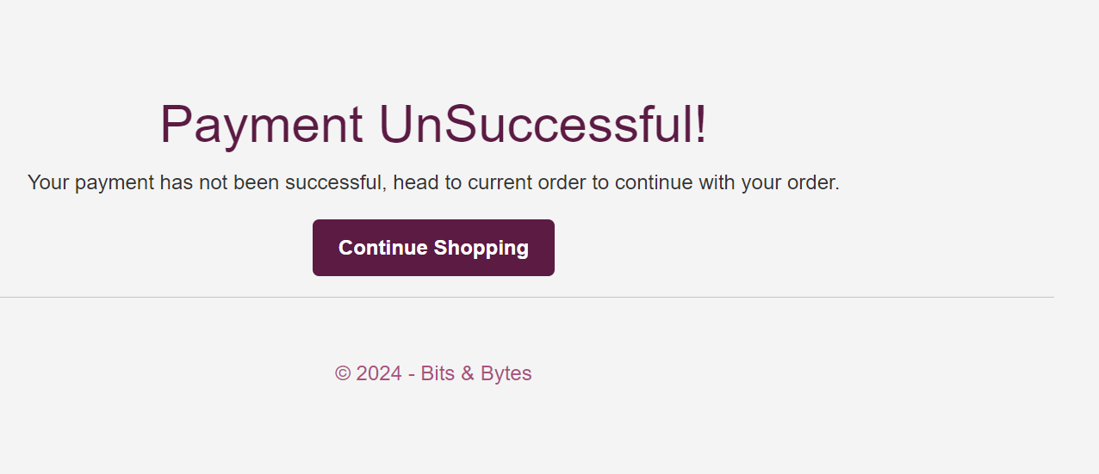

Pic100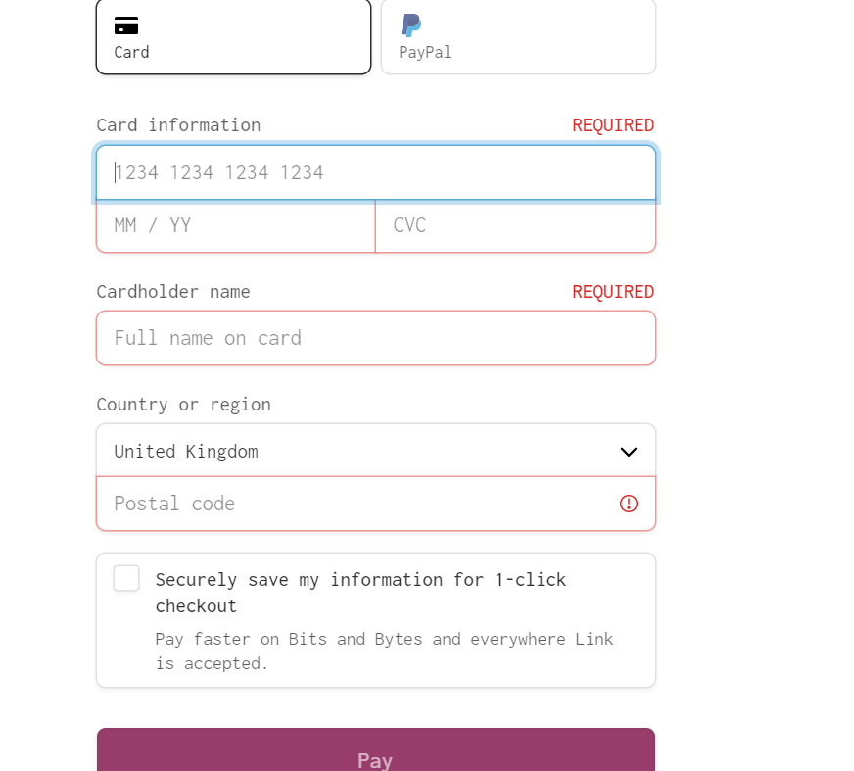

Pic 101

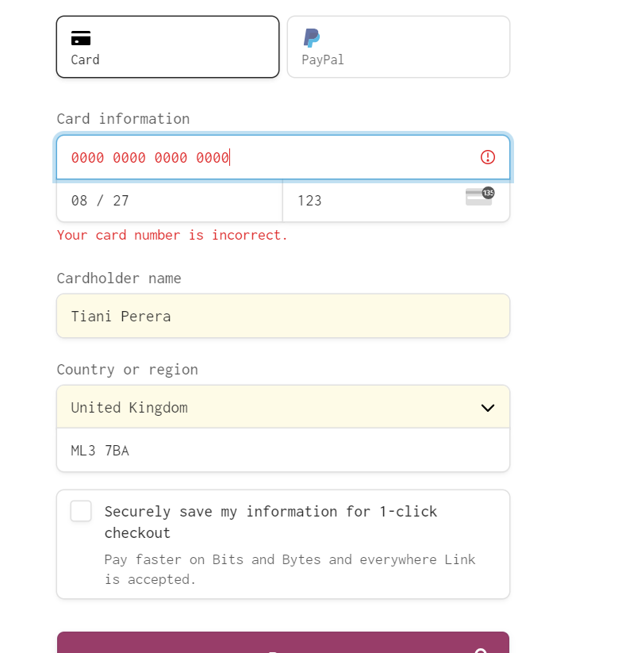

Pic 102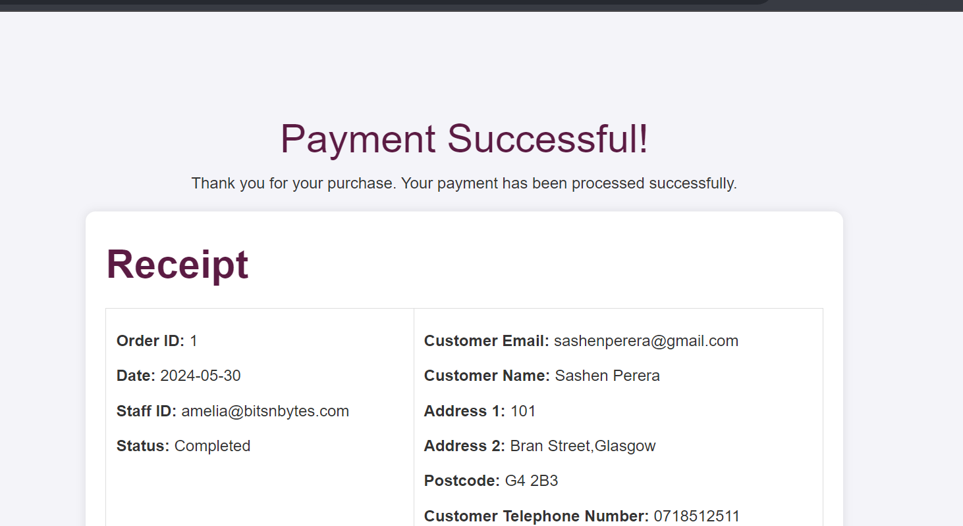

Pic 103

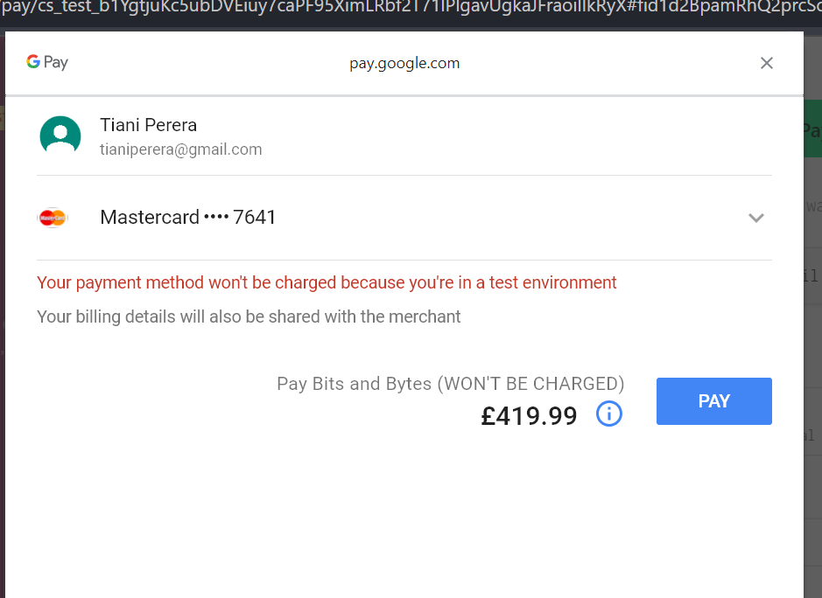

Pic 104

Pic 105

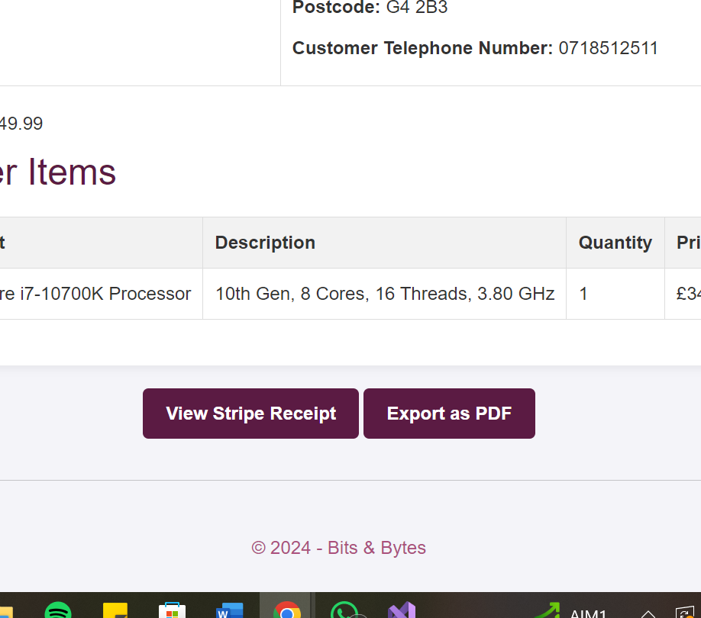

Pic 106

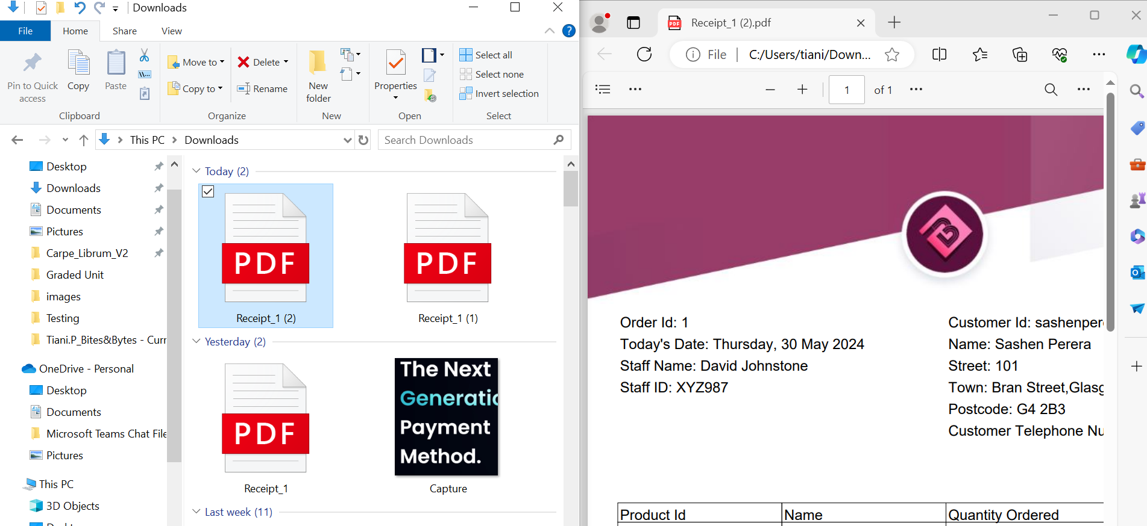

Pic 107 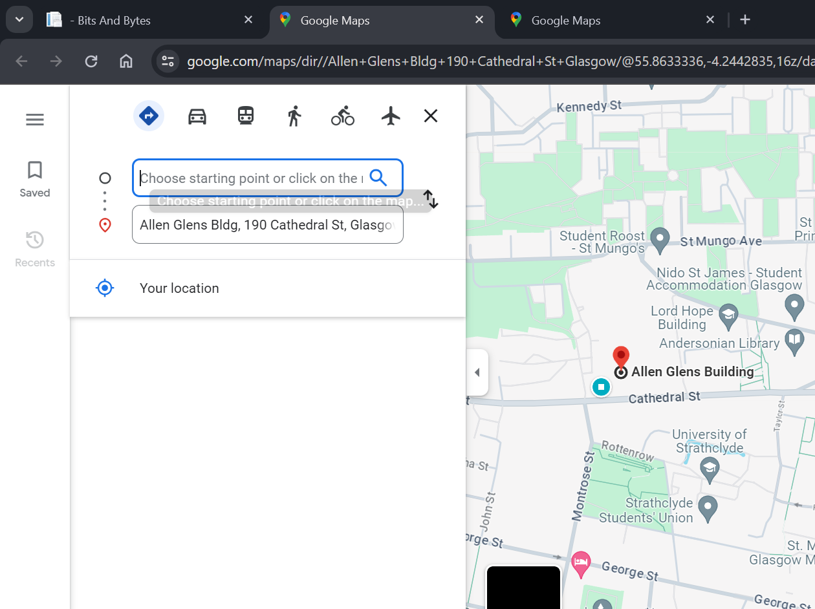

Pic 108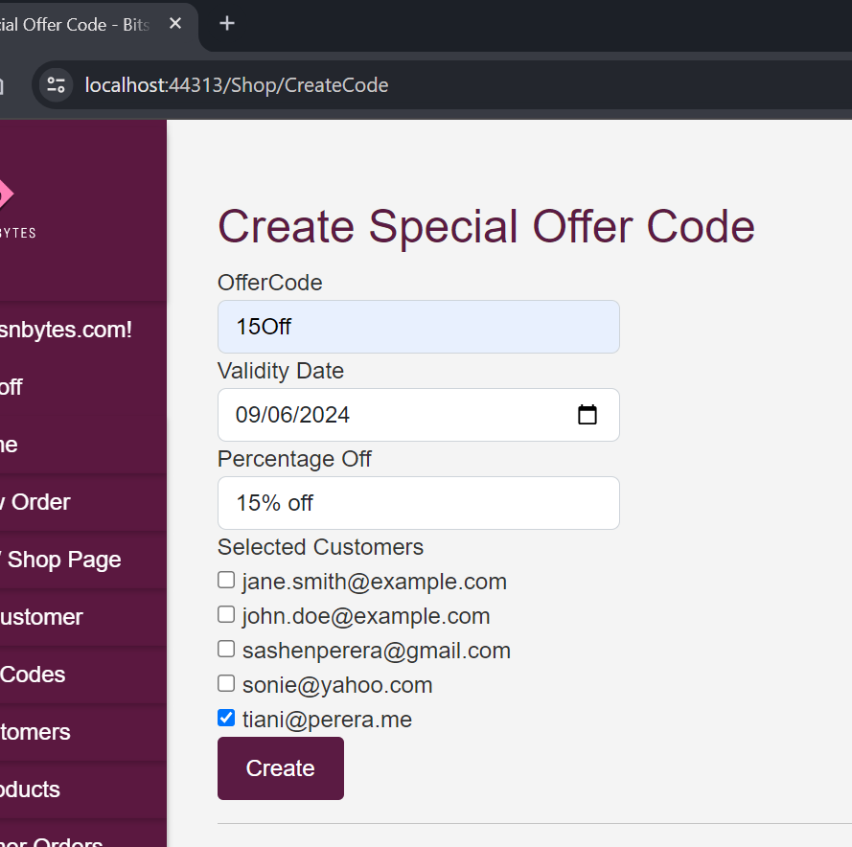

Pic 109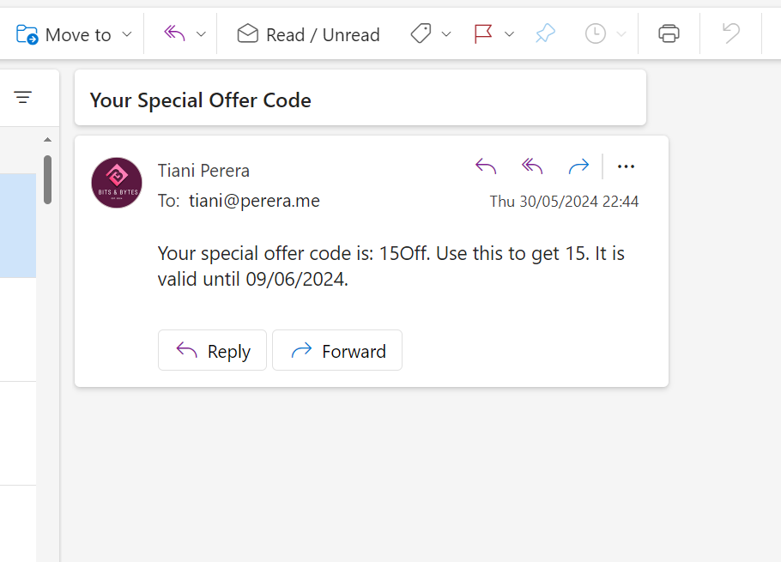

Pic110

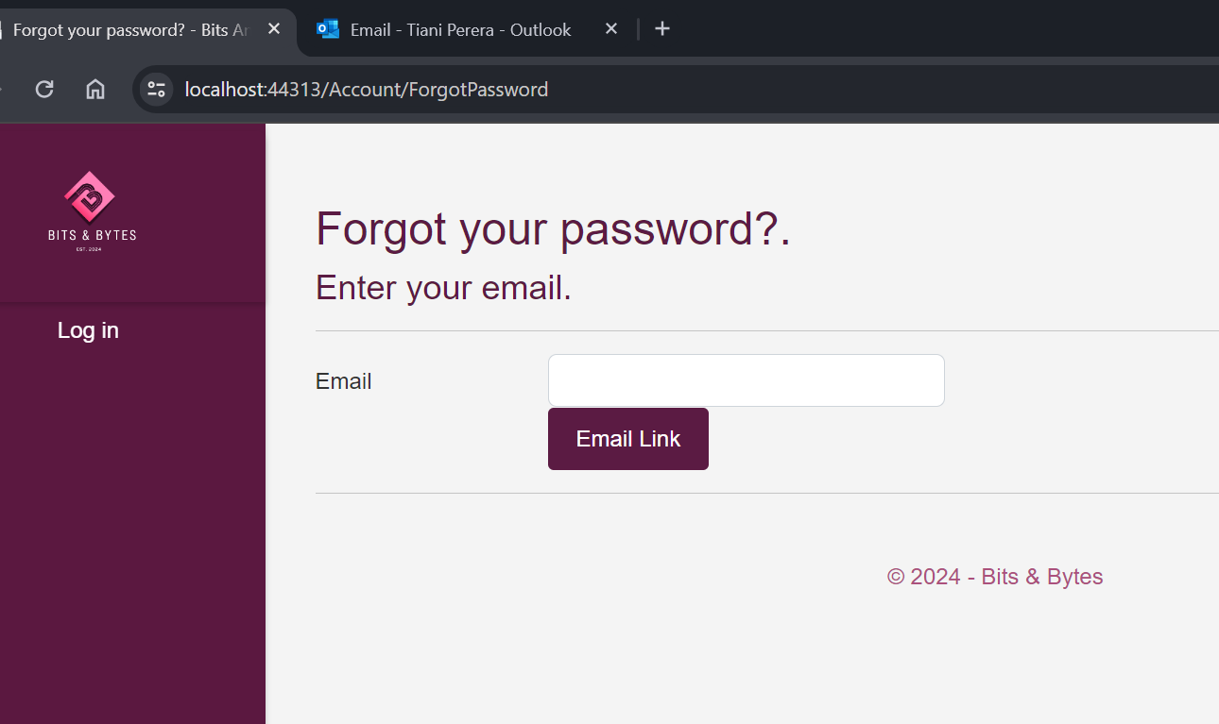

Pic 111

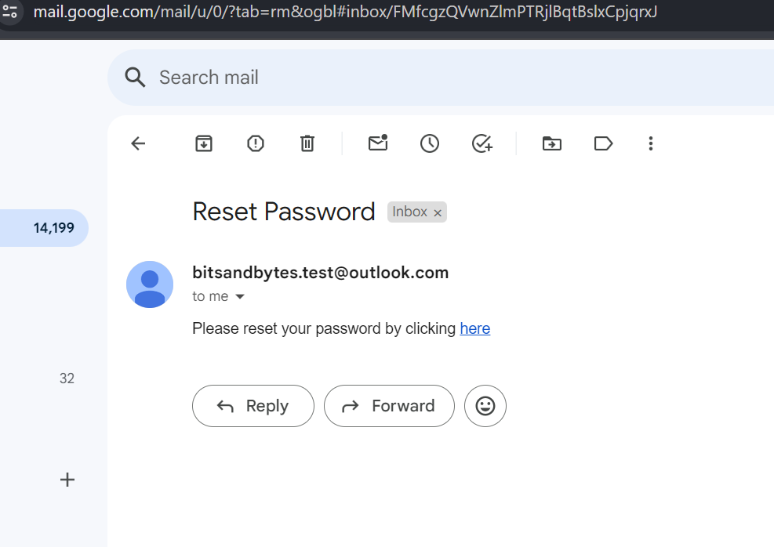

Pic 112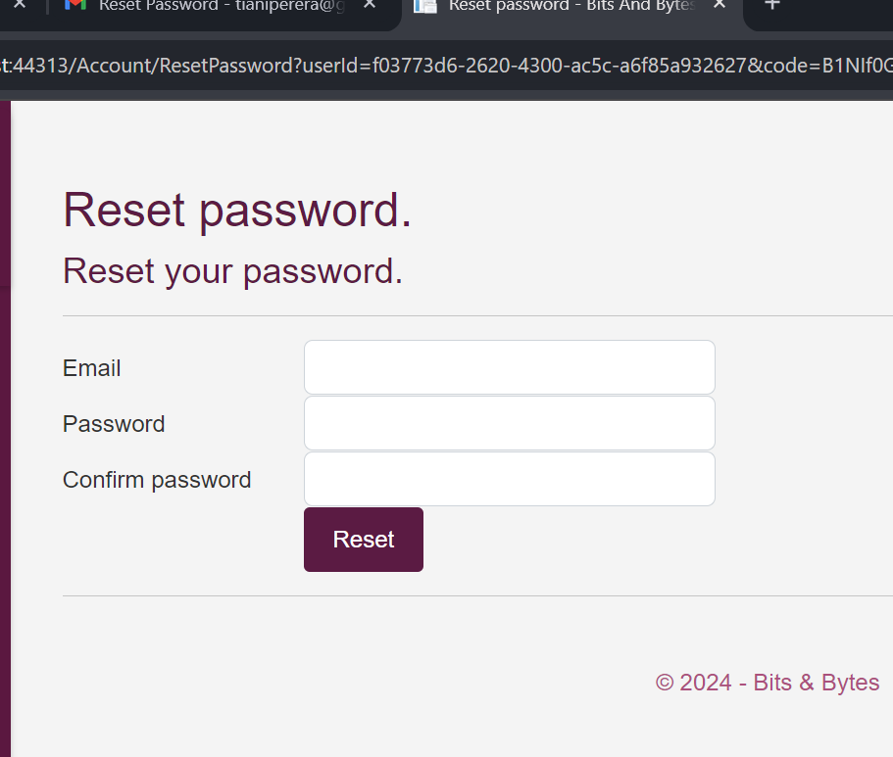

Pic 113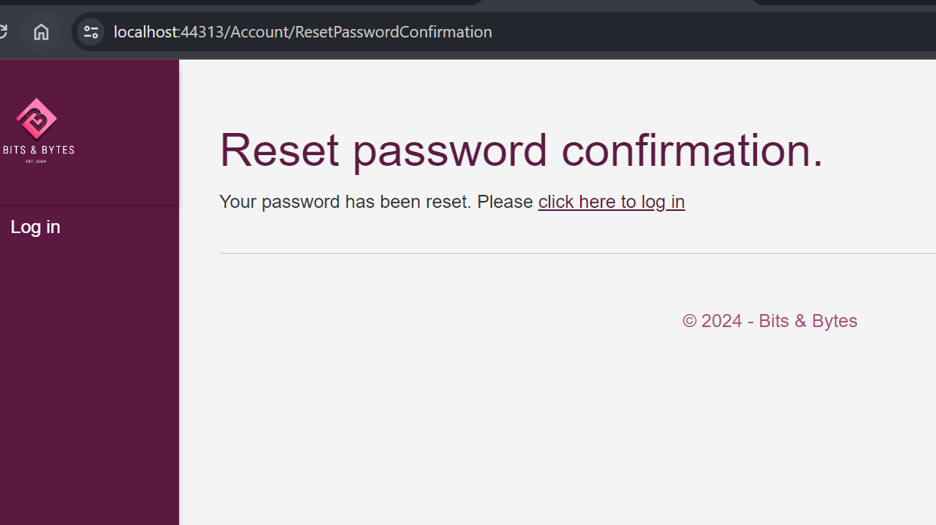

Pic 114

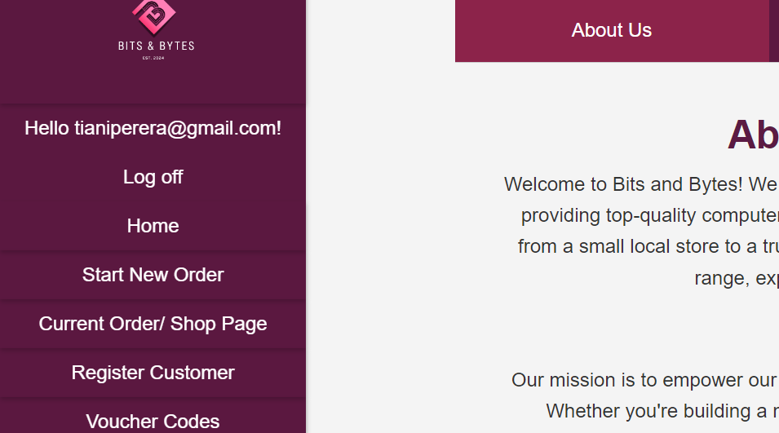

Pic 115

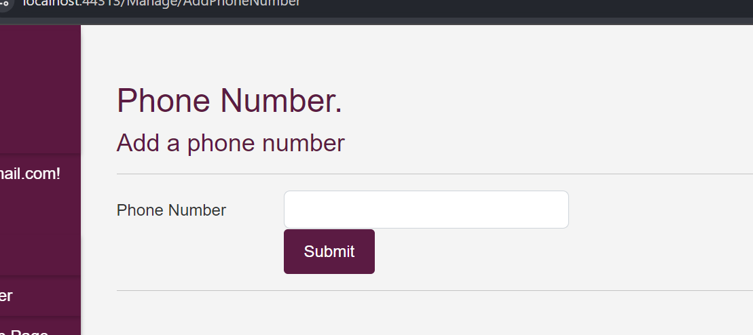

Pic 116

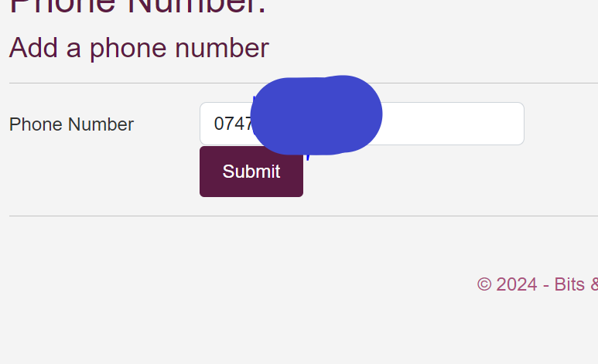

Pic117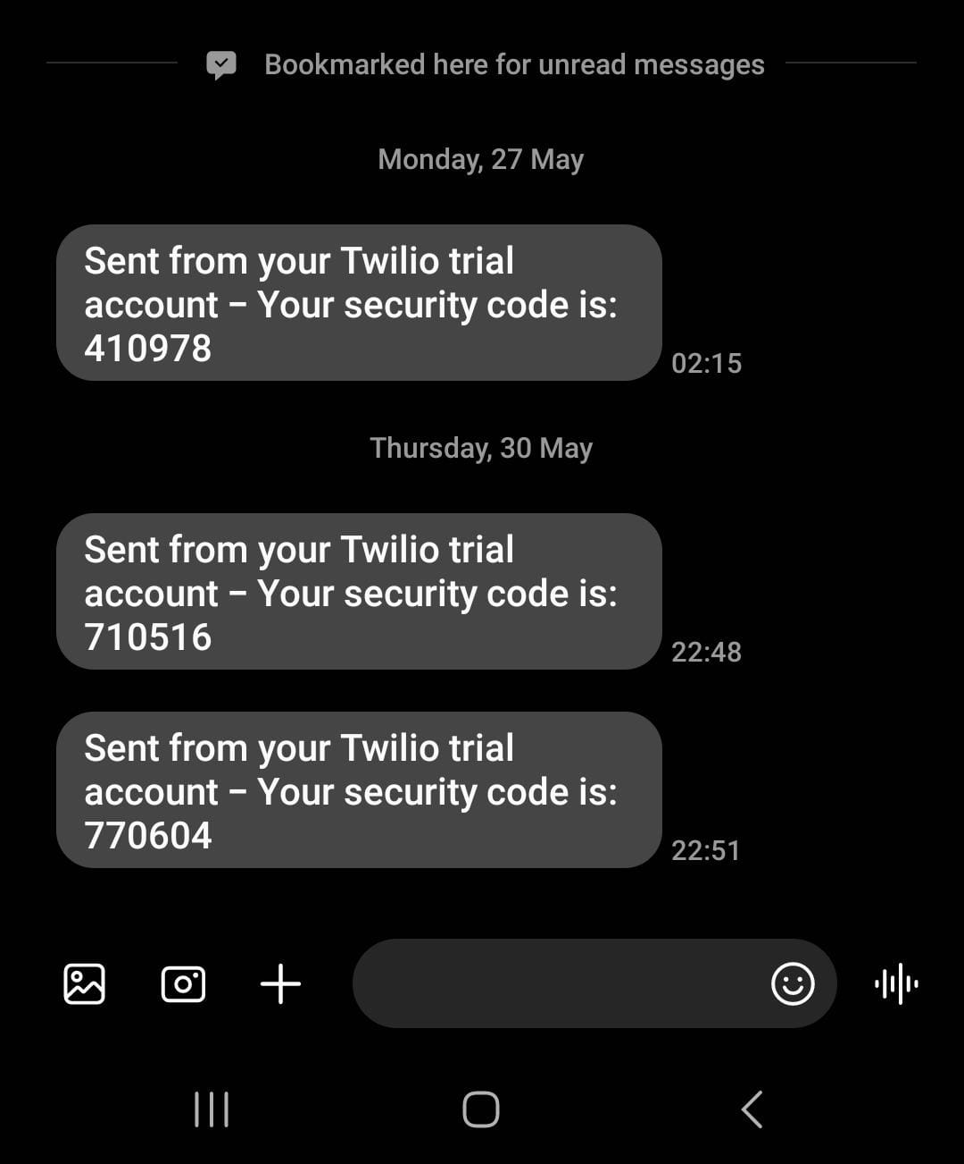

Pic 118

